Project Report on

World Happiness Report 2024

using

Machine Learning

Submitted by

Name: JERENITTE MATHEW

Reg No: 62522144012

In partial fulfilment of the award for the degree of

Master of Science in Statistics

Course Code: 625

Subject Code: ST 546

University College Thiruvananthapuram

Department of statistics

2022-2024

**TABLE OF CONTENTS**

Chapter 1: Introduction 3

1.1 Motivation of the study 4

1.2 Objective of the study 5

Chapter 2: Review of literature 6

2.1 World Happiness Report 6

2.2 Related works 7

Chapter 3: Methodology 9

3.1 Data 9

3.2 Introduction to Artificial Intelligence and Machine Learning 10

3.2.1 Artificial Intelligence (AI) 10

3.2.2 Machine Learning (ML) 11

3.3 Deep learning 18

3.4 Python 19

3.4.1 Python Libraries 20

3.4.2 Importance of Python language in AI 21

3.5 Data Preparation 21

3.5.1 Data preprocessing in ML 22

3.5.2 Data cleaning 23

3.5.3 Exploratory Data Analysis 24

3.5.4 Data visualization 24

Chapter 4: Data analysis 26

4.1 About the data set 26

4.2 Specification of the system 27

4.3 Data Preparation 28

4.4 Data Visualization 29

4.5 Model Optimization 35

4.6 Model Evaluation and Selection 38

Chapter 5: Results and discussion 40

Chapter 6: Conclusion 42

Chapter 7: Appendix 44

Bibliography 57

Chapter 1: Introduction

Happiness, often regarded as the ultimate pursuit of human existence, transcends mere material wealth and encompasses a multifaceted state of well-being encompassing aspects like work satisfaction, social connections, physical health, and personal fulfilment. The concept of happiness has woven its threads throughout the tapestry of human civilization, finding resonance in ancient cultures like those of Hinduism and Greek philosophy. In modern times, the pursuit of happiness has gained significant recognition as a vital component of sustainable development, intertwining with notions of personal well-being, societal progress, and environmental sustainability.

The United Nations, recognizing the paramount importance of happiness in fostering global harmony and prosperity, established the International Day of Happiness on March 20th through Resolution 66/281 in 2012. This annual observance underscores the collective commitment to advancing happiness and well-being as universal goals, transcending geographical, cultural, and socio-economic boundaries. The thematic focus of the International Day of Happiness 2024, "Reconnecting for Happiness: Building Resilient Communities," resonates deeply in an era marked by unprecedented challenges and uncertainties, emphasizing the transformative power of human connection and positivity.

Central to the understanding and pursuit of happiness is the World Happiness Report, a seminal document that evaluates happiness levels across nations based on a spectrum of factors ranging from economic prosperity to social support systems and environmental sustainability. Initiated in 2012, this report serves as a beacon guiding policymakers, researchers, and individuals alike towards a deeper comprehension of the intricacies of happiness and its determinants. With each iteration, the World Happiness Report sheds light on the evolving landscape of global well-being, offering insights into the drivers of happiness and avenues for fostering collective prosperity.

Against this backdrop, our project endeavors to delve into the World Happiness Report 2024 using advanced machine learning (ML) techniques and Python programming. By harnessing the power of data analytics and predictive modeling, we aim to unravel the intricate web of factors influencing happiness scores, exploring questions ranging from the impact of economic prosperity to the role of social cohesion and individual freedoms. Through this endeavor, we seek not only to deepen our understanding of happiness but also to empower stakeholders with actionable insights for fostering happier, more resilient societies in an ever-changing world.

This Project Report begins with introduction, motivation behind the study, significance and scope, including the objectives of this research. Review of literature deals with The World Happiness Report 2024 dataset and related works on previous WHR datasets. Chapter 3 methodology discuss on the topics Artificial Intelligence, Deep learning, Machine learning and its’ approaches and algorithms, Python Programming, Data preparation, Need for data preprocessing in AI, Data cleaning, Data visualization and so on. The upcoming chapter data analysis is displaying the data preparing and data analysis using ml approaches and model evaluation and model selection procedures. Finally, we present our findings, results and their implications. At last, in the appendix part, we included the print out of the Jupyter notebook.

This research helps us understand the features and conditions that lead to happiness relying on the world happiness report such as: economic conditions, social support, life expectancy and more. Using Machine Learning approaches, we can analyse and understand the features and conditions that lead to happiness based on the World Happiness Report 2024.

1.1 Motivation of the study

The aim and motivation behind doing machine learning (ML) projects using Python and for choosing the topic World happiness Report Analysis is multifaceted.

**Some common aims include:** Skill Development, Learning- To understanding of machine learning concepts, algorithms, and methodologies, Hands-on Experience- Applying theoretical knowledge in practical scenarios to solidify learning and improve problem solving skills and so on.

**On the topic:** Every person has a vital role in shaping the social, economic, political, and cultural landscape. Therefore, individual happiness is essential for the overall well-being of the state. Happiness significantly impacts mental, emotional, and physical health. Machine Learning techniques aid in data exploration and comprehension. By utilizing a variety of machine learning methods, we can analyse the factors influencing happiness and their inter relationships. This analysis helps in defining a country's happiness index and offers insights on enhancing individual well-being for national development.

The dataset here using has been obtained from the official World Happiness Report website. The project centres on determining happiness scores of countries using six key factors, pinpointing correlations between variables to target enhancements. The report is widely acknowledged globally as governments, businesses, and civil society increasingly leverage happiness metrics to shape policy decisions. Experts from various disciplines such as economics, psychology, survey analysis, national statistics, health, and public policy illustrate how measures of well-being effectively gauge a nation's advancement. It evaluates the present global happiness status and demonstrates how the science of happiness uncovers variations in happiness levels on both individual and national levels.

Studying world happiness provides valuable insights that can enhance personal well-being, inform public policy, and contribute to social and economic development. It emphasizes the importance of measuring and fostering well-being as a central goal of societies, going beyond traditional metrics like economic output. By working with industry-based data, this project aims to equip individuals with the tools and techniques necessary for predictive modelling, enhancing their understanding of machine learning and its applications in analysing and interpreting complex datasets related to global happiness.

1.2 Objective of the study

* Programmatically download and analyse data.
* Exploring how to calculate world happiness scores.
* Analyse the relationship between various socio-economic factors and happiness.
* To build predictive models using multiple regression and polynomial regression to estimate happiness scores based on these factors.
* Derive vital inquiries from the data like;

-Does the world happiness score rely on the economy GDP per capita?

-Does the Health life expectancy lead to happy life?

* Learn data visualization.
* Making inferences from the evaluation metrics.
* Master the art of data analysis by using Jupyter notebooks.
* Gain insight into the role of a Data Scientist.
* Explain machine learning.
* Learn the tools and techniques for predictive modelling.
* Discuss machine learning algorithms and their implementation.
* Validate machine learning algorithms.

Chapter 2: Review of literature

2.1 World Happiness Report

Happiness, often understood as the state of fulfilment, it encompasses various domains such as work, strong relationships, health, and Physical Well-being. Thus, it is a dream goal to be achieved by governments and individuals. Definition of happiness can vary from person to person. Happiness is increasingly recognized as a vital element in sustainable development, as it links to personal well-being, environmental sustainability, and societal advancement.

On July 12, 2012, the United Nations General Assembly established the International Day of Happiness through resolution 66/281. This annual celebration on March 20th acknowledges the urging for a global effort to advance happiness and well-being. The resolution underscores the necessity for a more equitable and inclusive approach to economic growth that places importance on long-term development, poverty alleviation, and the happiness and well-being of all individuals. International Happiness Day is garnering heightened attention, with numerous entities, individuals, and even governments actively endorsing its message. Emphasis on specific themes: Every year, a distinct theme is selected to steer the Day's engagements and conversations, addressing a range of happiness and well-being aspects[1].

The official theme for International Day of Happiness 2024 is “Reconnecting for Happiness: Building Resilient Communities”. This day carries various connotations, emphasizing the influence of a simple smile. A single uplifting message or gesture can bring joy to individuals worldwide. Happiness Day can be observed in diverse ways. Some individuals arrange events and activities to advocate happiness and well-being, while others share positive messages and quotes on social media. Numerous organizations and governments worldwide leverage this day to introduce initiatives and policies that support happiness and well-being [2]. At the Global Level the International Day of Happiness serves as a reminder to the world that happiness is not merely an individual pursuit but a fundamental human goal that should be prioritized globally. The day acts as a platform for advocating for policies and actions that prioritize well-being, such as ensuring access to education, healthcare, and social safety nets. Overall, the International Day of Happiness serves as a compelling reminder of the importance of well-being and its role in shaping a better world. It encourages individuals to actively seek happiness and cultivate positive relationships[2]. There is a growing consensus on the methods for measuring happiness, making it a tangible goal for governments.

Measuring happiness is challenging due to the varied definitions of Happiness[3]. The World Happiness Report, which assesses individuals’ self-evaluations in over 150 countries through global surveys, has played a significant role in this shift. Collaborators on the World Happiness Report include Gallup, the Oxford Wellbeing Research Center, the UN Sustainable Development Solutions Network, and the WHR’s Editorial Board. Starting in 2024, the report will be published by the Wellbeing Research Center at the University of Oxford in the United Kingdom. The Happiness Score is derived from the national average of responses to the primary life evaluation question in the Gallup World Poll (GWP), which employs the Cantril Ladder. Since the inception of the International Day of Happiness, an increasing number of individuals have embraced the idea that the well-being of a nation should be based on the happiness of its citizens. The inaugural World Happiness Report is published, evaluating happiness levels across nations based on factors such as income, health, social support, and freedom. In the issue of the World Happiness Report 2024 it focuses on the happiness of people at different stages of life. It explores the latest findings on the happiness of the world’s young, the old and everyone in between[4].

Data from the Gallup World Poll is utilized to calculate happiness scores and rankings based on responses to the main life evaluation question in the survey. This dataset is reliable, with the six components of happiness being separately estimated in columns following the happiness score: Gross Domestic Product, Social support, Healthy life expectancy, Freedom to make life choices, Perception of corruption, Dystopia and generosity, these are explained briefly in the upcoming Section. Happiness Scores represent national average responses to life evaluation questions and can assist in predicting the next year’s world happiness index, providing insight into people’s current life quality. The dataset analysed by the authors can aid in future research and decision-making processes to explain variations in happiness rankings among countries. These factors are crucial in emphasizing that happiness is rooted in social capital, not solely financial gain. Happiness serves as a vital tool in shaping public policies and evaluating their impact. It is worth noting that happiness scores underscore the significance of qualitative aspects over quantitative ones, highlighting the value of quality over quantity. Finland has secured the title of the happiest country in the world for seven consecutive years.

2.2 Related works

This section provides an overview of research conducted using machine learning and statistical methods to analyse various country-level indicators of happiness quality from the World Happiness Report. The works are presented chronologically, the analysis study [5]overs the underlying behaviour and meaning of the data provided by the World Happiness Report (WHR). The data includes six parameters that the WHR uses to calculate world rankings. From the data analysis, several issues with the growth of the world as a whole and the lack of resources in the trailing countries can be inferred. Research [6]explores physical and mental needs, including education, as factors influencing a nation’s overall happiness. More than 90 features are identified as predictors of a country’s happiness. Due to the large number of features, manual analysis is impractical; therefore, support vector machines (SVM) and the information gain dimensionality reduction technique are used for happiness prediction. The SVM model achieved an accuracy of nearly 90%. Data from 187 countries sourced from the UN Development Project is utilized to pinpoint areas needing improvement to enhance citizens’ happiness. The article [3]concludes 5 years of happiness scores data including family, Gross Domestic Product (GDP), health, freedom, generosity trust, and dystopia residual. Happiness scores are considered appropriate indicators to measure the progress of social development. In another study [7], researchers analyse the World Happiness Index using regression analysis and correlation to address calculation issues associated with this index based on seven components from the 2016 World Happiness Report for 156 countries. Research[8] develops a happiness prediction model employing machine learning algorithms like NB, K-nearest neighbor (KNN), MLP, and Decision Tree (DT) based on survey data collected from Ministry of Public Health employees in Thailand. The study tackles imbalanced data and achieves an overall prediction accuracy of 88.19% with DT. Another study [9] focuses on analysing the happiness index in Southeast Asia using the World Happiness Report 2020 dataset. The researchers use exploratory data analysis (EDA) techniques to explore, analyse, and visualize the data. Insights and recommendations for further data science processes and building data models are based on the EDA results. Authors of study[10] combine two datasets – the happiness report dataset and the COVID-19 dataset containing confirmed cases from multiple countries to apply various machine learning algorithms including linear regression, KNN, NB, SVM, and logistic regression. These algorithms are employed to construct predictive classification and regression models to meet various research objectives. Regression analysis, correlation techniques, and EDA are frequently used for analysis in these studies. In our research, we utilize EDA and statistical techniques like Pearson correlation and principal component analysis to explore associations within our data. Furthermore, we apply machine learning methods to delve deeper into the impact of objective factors on the happiness score of the World Happiness Index[11].

Chapter 3: Methodology

3.1 Data

Data refers to raw, unprocessed facts and figures that are collected for reference, analysis, and decision-making. These can be numbers, text, images, or other types of input that, on their own, may not carry much meaning. However, when data is processed, organized, and analysed, it can provide valuable information and insights.

Types of Data:

Data can be of various forms, such as structured, semi-structured, or unstructured. Besides, the “metadata” is another type that typically represents data about the data. In the following, we briefly discuss these types of data[12].

1. **Structured**: The data has a clear structure that adheres to a standardized format, making it organized, accessible, and utilized by an individual or software program. In structured systems like relational databases, data is usually stored in a tabular form. Examples of structured data include names, dates, addresses, credit card numbers, stock information, and geolocation.
2. **Unstructured**: Unstructured data is the data that lacks any predefined model or format. It requires a lot of storage space, and it is hard to maintain security in it. It cannot be presented in a data model or schema[13]. Unstructured data doesn’t fit neatly into a data table because its size or nature: for example, audio and video files and large text documents.
3. **Semi-structured**: Semi-structured data is not stored in a relational database like structured data. However, it possesses specific organizational properties that facilitate analysis. Examples of semi-structured data include HTML, XML, JSON documents, and NoSQL databases.
4. **Metadata**: It is not the standard type of information, but rather known as "data about data". The main distinction between "data" and "metadata" lies in the fact that data is simply the material that can classify, measure, or document something in relation to an organization's data properties. Conversely, metadata provides descriptions of the pertinent data information, adding more importance for data users. An elementary example of metadata for a document could include details such as the author, file size, date of document creation, and keywords used to categorize the document.

3.2 Introduction to Artificial Intelligence and Machine Learning

Data science is evolving towards a new era in which machines can be trained to extract valuable insights from data, leading to the development of artificial intelligence. Data science and machine learning are closely intertwined, with machine learning being a branch of artificial intelligence that focuses on enabling machines to learn from data. Data science plays a crucial role in assessing data for machine learning algorithms. While data science, machine learning, and artificial intelligence are interconnected and belong to the same field, each has distinct applications and significance. The first approaches to AI appeared in the 1960s and 1970s years of the last century. Artificial Intelligence (AI) was funded by the “Dartmouth Summer Research Project on Artificial Intelligence” academic [14].

3.2.1 Artificial Intelligence (AI)

AI is a type of Intelligence exhibited by machines that mimics human and animal intelligence. AI is redefining industries and increasing personalization and automation. According to the cognitive modelling (i.e., thinking humanly) stream, AI instantiations must be “machines with a mind” [15] that perform human thinking [16]. The Turing test stream (i.e., acting humanly) implies that AI must act intelligently when interacting with humans. To accomplish such tasks, AI instantiations must perform human tasks at least as well as humans[17],[18]. It lies at the core of many activity sectors that have embraced new information technologies [19]. While the roots of AI trace back to several decades ago, there is a clear consensus on the paramount importance featured nowadays by intelligent machines endowed with learning, reasoning and adaptation capabilities.

**Features of Artificial Intelligence**

* Natural language processing
* Machine learning
* Computer vision
* Robotics
* Problem solving
* Logical reasoning
* Anomaly detection and so on.

**Applications of Artificial Intelligence**

* Self-driving cars
* Google’s AlphaGo
* Chess
* Amazon collects data from users and recommends the best products according to the user’s buying/shopping pattern.
* Data Security
* Robotics
* E-commerce etc.

3.2.2 Machine Learning (ML)

In a computer program, data and output are run to create a program based on patterns from data, Artificial Intelligence systems learn by extracting patterns from data. Machine learning is a key aspect of artificial intelligence (AI), a sub-field of computer science. The terms "data science" and "big data" are commonly associated with machine learning, but there is a distinct difference. Machine learning encompasses a variety of algorithms that aim to learn from existing data and apply that knowledge to new cases. Machine learning addresses the question of how to build computers that improve automatically through experience also it relies on learning patterns based on sample data.

Machine learning involves computer algorithms learning knowledge from examples and applying that knowledge to unknown cases. The program searches for inherent patterns within large amounts of data. Unlike traditional computer programs with fixed sequences of commands to complete tasks, the outcomes of machine learning algorithms depend on the available data. ML describes a set of methods commonly used to solve a variety of real-world problems with the help of computer systems, which can learn to solve a problem instead of being explicitly programmed to do so [20]. The ML procedure is comparable to one young data scientist who has gained his knowledge from a wide range data over time. While the young scientist did this for months or years, the computer can process millions of data “Look through” minutes, analyse and learn from them. Because of Given the huge number of cases analysed, ML can make connections recognize the data that remains hidden to humans. Add It's because we humans don't perceive more than three dimensions can, while computers can also handle several thousand dimensions can work. Furthermore, we have in contrast to the computer it is difficult to establish non-linear relationships recognize. But since most biological phenomena are not linear are, we find an assignment especially if they are present difficult or even impossible for several factors[21].

In general, the effectiveness and the efficiency of a machine learning solution depend on the nature and characteristics of data and the performance of the learning algorithms. Machine learning algorithms use structured, labelled data to predict outcomes by defining specific features from input data and arranging them in tables. Although they can also handle unstructured data, this usually requires pre-processing to structure it. In the area of machine learning algorithms, classification analysis, regression, data clustering, feature engineering and dimensionality reduction, association rule learning, or reinforcement learning techniques exist to effectively build data-driven system ([22], [23]). Besides, deep learning originated from the artificial neural network that can be used to intelligently analyse data, which is known as part of a wider family of machine learning approaches [24]. Thus, selecting a proper learning algorithm that is suitable for the target application in a particular domain is challenging. The reason is that the purpose of different learning algorithms is different, even the outcome of different learning algorithms in a similar category may vary depending on the data characteristics [25]. It's crucial to comprehend the concepts behind different machine learning algorithms and how they can be used in real-world applications like IoT systems, cybersecurity, business and recommendation systems, smart cities, healthcare, context-aware systems, sustainable agriculture, and more. Real-world data and machine learning techniques analyse data to understand patterns related to individuals, business operations, transactions, events, and other aspects.

**Machine Learning Types**

Machine Learning uses a number of theories and techniques from Data Science. Machine Learning algorithms are mainly divided into four categories: Supervised learning, Unsupervised learning, Semi-supervised learning, and Reinforcement learning.

**Supervised Learning** – Supervised Machine learning that uses labelled datasets to train algorithms to predict outcomes and recognize patterns. SL methods always aim to build a model by applying an algorithm to a set of known data points to gain insight into an unknown set of data[26]. Supervised machine learning creates a model that makes predictions based on evidence in the presence of uncertainty [26]. It utilizes classification and regression methods to create machine learning models. Classification models categorize the input data, predicting discrete outcomes like determining if an email is authentic. Regression methods forecast continuous outcomes, such as variations in temperature or shifts in electricity demand.

Applications of supervised Learning:

* Spam Filtering
* Image Classification
* Fraud Detection
* Natural Language Processing

**Unsupervised Learning** - Unsupervised learning in artificial intelligence is a type of machine learning that learns from data without human supervision. Unlike supervised learning, unsupervised machine learning models are given unlabelled data and allowed to discover patterns and insights without any explicit guidance or instruction [27]. Clustering and association are the main unsupervised learning technique. Clustering as an approach can be used to Segment audience or customer data into groups in marketing environments. Association rules can be used to Recommend products and services to customers depending on their buying habits.

Applications of Unsupervised Learning:

* Customer Segmentation
* Anomaly Detection
* Image and Text Clustering
* Genome Analysis

**Semi-supervised learning -** So-called semi-supervised learning combines elements from supervised and unsupervised ML by jointly using labelled and unlabelled data [28]. Supervised learning is different from SSL, which can be applied to various problems including classification, regression, clustering, and association. Semi-supervised learning aims to develop a function that accurately predicts the output variable using input variables.

Applications of semi-supervised Learning:

* Speech Analysis
* Internet Content Classification
* Protein Sequence Classification

**Reinforcement learning** - Reinforcement learning refers to methods that are concerned with teaching intelligent agents to take those kinds of actions that increase their cumulative reward [29]. Reinforcement Learning relies on feedback, where an agent learns how to act in an environment by taking actions and observing their outcomes. When the agent makes a good move, it receives positive feedback, but it receives negative feedback or a penalty for making a bad move. There are mainly two types of reinforcement learning, which are: Positive Reinforcement and Negative Reinforcement.

Applications of Reinforcement Learning:

* Robotics: In Robot navigation, Robo-soccer, walking, juggling, etc.
* Control: such as Factory processes, admission control in telecommunication.
* Game Playing: tic-tac-toe, chess, etc.

Therefore, various machine learning types can significantly contribute to the development of effective models in different application areas, depending on their learning capabilities, the nature of the data previously mentioned, and the desired outcome.

The Machine Learning techniques are (detailed explained in the next section);

* Classification - classification is a method where a computer program learns from input data and uses this knowledge to classify new observations.
* Categorization - Categorization involves organizing data into categories for optimal use.
* Clustering - Clustering is the process of grouping objects so that those in the same group are more similar to each other than to those in other groups.
* Trend analysis - Trend analysis projects current and future event movements using time series data analysis.
* Anomaly detection - Anomaly detection identifies unusual cases within seemingly uniform data.
* Visualization - Visualization presents data visually, aiding decision-makers in understanding analytics.
* Decision making - Decision making is a skill that empowers influencing managerial decisions with data as supporting evidence.



Fig 1. Various types of machine learning techniques

**Machine Learning Techniques**

**Supervised Learning:** Classification andRegression

* Linear/Logistic Regression

Logistic Regression (LR) is a classification model used to predict a binary dependent variable. Linear regression, on the other hand, is its counterpart when the dependent variable is continuous. LR assumes a linear relationship between predictors and predicted variables, which limits its flexibility in fitting the data. The model's explainability varies depending on the audience interpreting it. While logistic and linear regression align with transparent model characteristics, they may require post-hoc explainability techniques, such as visualization, especially for non-expert audiences. Despite logistic regression being a straightforward classification model in supervised learning, certain concepts need attention.

* Decision Trees

Model can be used for both classification and Regression problems, but mostly it is preferred for solving Classification problems. It is a tree-structured classifier, where internal nodes represent the features of a dataset, branches represent the decision rules and each leaf node represents the outcome. Decision tree is a graphical representation for getting all the possible solutions to a problem/decision based on given conditions[30].

* Random forest

Random Forest is a machine learning technique that involves multiple decision trees. Each tree in a Random Forest makes a prediction, and the outcome with the most votes is chosen as the final prediction. By combine their predictions from all decision trees, the overall accuracy can be significantly increased.

* Neural Networks

Models inspired by the human brain, consisting of interconnected layers of nodes (neurons) that learn representations of the data. Neural networks are a type of machine learning that are also referred to as artificial neural networks. Each artificial neuron is linked to multiple other neurons within the network, forming a complex cognitive framework.

* Support Vector Machines (SVM)

The support vector machine, commonly referred to as SVM, is a well-known machine learning algorithm utilized for classification and regression tasks. Finds the hyperplane that best separates the classes in the feature space. The ideal decision boundary, termed a hyperplane, is determined by SVM through the selection of extreme vectors, also known as support vectors.

* Naïve Bayes

 It is based on Bayes theorem and follows the naïve(independent) assumption between the features which is given as:



Each naïve Bayes classifier assumes that the value of a specific variable is independent of any other variable/feature. For example, if a fruit needs to be classified based on colour, shape, and taste. So yellow, oval, and sweet will be recognized as mango. Here each feature is independent of other features.

**Unsupervised Learning:** Clustering and Association

* K-Means Clustering

This method is utilized for resolving clustering issues. Partitions the data into k clusters, where each data point belongs to the cluster with the nearest mean. This implies that data sets with the greatest similarities are grouped together in one cluster, which has minimal or no similarities with other clusters. In K-means, K denotes the quantity of clusters, and means pertains to the averaging of the data set to identify the centroid.

* Hierarchical Clustering

It is to group the unlabelled datasets into a cluster and also known as hierarchical cluster analysis. Builds a tree of clusters by either merging or splitting existing clusters iteratively. Clustering that uses only similarities of instances, without any other requirement on the data; the aim is to find groups such that instances in a group are more similar to each other than instances in different groups. This is the approach taken hierarchical by hierarchical clustering[31].

* Association Rules

Identifies relationships between variables in large datasets, commonly used for market basket analysis. The main aim of this learning algorithm is to find the dependency of one data item on another data item and map those variables accordingly so that it can generate maximum profit ([32], [33], [34]).

**Features of Machine Learning**

* It uses the data to detect patterns in a dataset and adjust program accordingly.
* It focuses on the development of computer programs that can teach and change when exposed to new data.
* It enables computers to find hidden insights using iterative algorithms without being explicitly programmed.
* It automates analytical model building.

**Relationship** between **Machine Learning and Data Science**

Figure 2: Relationship between Machine Learning and Data Science

**Applications of Machine Learning**

* Predictive analytics and intelligent decision-making
* Cybersecurity and threat intelligence
* Traffic prediction and transportation
* NLP and sentiment analysis
* Image, speech and pattern recognition
* User behaviour analytics and context-aware smartphone applications.

3.3 Deep learning

Deep learning is a subset of machine learning that uses multi-layered neural networks, called deep neural networks, to simulate the complex decision-making power of the human brain. There are several architectures used in deep learning such as deep neural networks, deep belief networks, recurrent neural networks, and convolutional neural networks. These networks have been successfully applied in solving the problems of computer vision, speech recognition, natural language processing, bioinformatics, drug design, medical image analysis, and games[35]. Deep learning algorithms attempt to draw similar conclusions as humans would by constantly analysing data with a given logical structure. To achieve this, deep learning uses a multi-layered structure of algorithms called neural networks[36]. It enables computer models with multiple layers of processing to understand data through various levels of abstraction. Deep learning reduces the need for data pre-processing common in machine learning.

**Fundamental Concepts:**

* Neural networks: Neural networks are the core of deep learning, comprising layers of nodes, known as "neurons." Each neuron takes input, processes it with a weighted sum and an activation function, and transmits the output to the following layer.
* Deep learning consists of various layers:

1. Input Layer: The initial layer that receives the raw data.
2. Hidden Layers: Intermediate layers that handle inputs from the prior layers. Typically, deep learning models contain multiple hidden layers.
3. Output Layer: The ultimate layer that generates predictions or classifications.

* Activation functions: These are functions applied to each neuron's output to introduce non-linearity, enabling the network to grasp intricate patterns. Common activation functions include ReLU (Rectified Linear Unit), sigmoid, and tanh.
* Training: It involves adjusting the network weights using a dataset to minimize prediction errors. This process includes:

1. Forward Propagation: Sending inputs through the network to obtain outputs.
2. Loss Function: A measure of the variance between the predicted output and the actual target.
3. Backpropagation: An algorithm that adjusts weights by calculating the loss function gradient concerning each weight and updating the weights to minimize losses.
4. Optimization Algorithms: Methods like stochastic gradient descent (SGD), Adam, and RMSprop are utilized to update weights during training.

**Applications of Deep Learning:**

* Computer Vision: Object detection, facial recognition, and image generation.
* Natural Language Processing (NLP): Language translation, sentiment analysis, and chatbots.
* Speech Recognition: Converting spoken language into text.
* Autonomous Vehicles: Enabling self-driving cars to perceive and navigate the environment.
* Healthcare: Medical image analysis, predictive diagnosis, and personalized medicine.

**Deep Learning – Disadvantages:**

Some of the disadvantages on using deep learning are listed below:

* Black Box approach
* Duration of Development
* Amount of Data
* Computationally Expensive

3.4 Python

Python is powerful... and fast; plays well with others; runs everywhere; is friendly & easy to learn; is Open[37]. Python remains a widely-used programming language that was developed by Guido van Rossum and launched in 1991. In 1994, Python 1.0 was released with new features like lambda, map, filter, and reduce. Python 2.0 added new features such as list comprehensions, garbage collection systems. On December 3, 2008, Python 3.0 (also called "Py3K") was released. It was designed to rectify the fundamental flaw of the language[38].

Key features of Python programming are:

* Simple and Easy to Learn
* Interpreted Language , Embeddable
* Dynamically Typed
* High-Level Language
* Extensive Standard Library
* Cross-Platform Compatibility
* Object-Oriented and Functional Programming
* Readable and Maintainable Code
* Support for GUI Programming

3.4.1 Python Libraries

A collection of code scripts that can be used iteratively to save time is known as a library. A Python library is a collection of modules that are connected. It makes Python programming easier and simpler. They are heavily used in a variety of fields, including data visualization, machine learning, and computer science.

**Matplotlib** - Matplotlib is responsible for plotting numerical data.

**NumPy** - NumPy is a popular open-source Python package that focuses on scientific and mathematical computation.

**Pandas** - It is a widely used library in data science for data analysis, manipulation, and cleaning.

**Seaborn** -This package makes statistical model visualization possible.

The library, which is largely based on Matplotlib, makes statistical graphics possible by:

* Variable examination by means of a Programming interface in view of datasets.
* Make complex representations effortlessly, including multi-plot frameworks.
* To compare data subsets, univariate and bivariate visualizations are utilized.
* A wide range of colour schemes are available for pattern displays.
* Direct relapse assessment and plotting are done consequently[39].

**SciPy** - SciPy is a Python library used for scientific computing, data processing, and high-level computing.

**Scikit-learn** - Is a Python-based open-source machine learning library that supports supervised and unsupervised learning methods.

**TensorFlow** - TensorFlow is a fast, open-source library for numerical calculations used in machine learning and deep learning algorithms.

**Keras** - It is an open-source neural network library in Python that facilitates deep neural networks research.

Python's standard library and the community-contributed modules allow for endless possibilities like;

* Web and Internet Development
* Desktop GUIs
* Scientific & Numeric
* Education
* Network Programming
* Software & Game Development

3.4.2 Importance of Python language in AI

Python is a key part of AI programming languages due to the fact that it has good frameworks, such as scikit-learn-Machine Learning in Python that meets almost all requirements in this area. It is among the most efficient and user-friendly tools to visualize[40].

Python is required for AI because of the reasons:

* Simplicity of Python
* The efficient ecosystem of the library
* Independence of platform
* Easy integration with data processing and visualization
* The popularity of the real-world applications
* Flexibility while coding
* Less coding but more efficiency[41].

3.5 Data Preparation

Steps in data preparation:



Figure 3: Steps in data preparation

3.5.1 Data preprocessing in ML

Data preprocessing is a process of preparing the raw data and making it suitable for a machine learning model. That is, it involves cleaning and preparing raw data to facilitate feature engineering. It is the first and crucial step while creating a machine learning model[42].

Why Data Preprocessing ….?

A real-world data generally contains noises, missing values, and maybe in an unusable format which cannot be directly used for machine learning models. Data preprocessing is required tasks for cleaning the data and making it suitable for a machine learning model which also increases the accuracy and efficiency of a machine learning model[42].

How Data Preprocessing…...?

* Getting the dataset

The information gathered for a specific issue in the correct layout is referred to as a dataset. Each dataset varies from one another. Typically, we store the dataset in a CSV file to utilize it in our code.

* Importing libraries

Data preprocessing with Python requires importing specific Python libraries. NumPy is utilized for mathematical operations, matplotlib for 2D plotting (requiring the pyplot sub-library), and Pandas for importing and managing datasets.

* Importing datasets

Once the current directory is established as the working directory, the next step involves importing the datasets gathered for our machine learning project. To import the dataset, the read_csv () function of the pandas library will be utilized.

* Finding Missing Data

Having missing data in our dataset can significantly impact the performance of our machine learning model. As such, it is crucial to address any missing values within the dataset. Two common methods for handling missing data include removing the specific row or calculating the mean.

* Encoding Categorical Data

Machine learning models rely heavily on mathematics and numerical data. However, the presence of categorical variables in our dataset can cause issues during model development. Therefore, it is crucial to convert these categorical variables into numerical values. To achieve this, we will utilize the LabelEncoder () class from the preprocessing library.

* Splitting dataset into training and test set

Splitting the dataset into a training set and a test set is a critical data preprocessing step that can improve the performance of a machine learning model. The training set is a portion of the dataset used to train the model, with known outputs. The test set is a portion of the dataset used to evaluate the model, where the model predicts the outputs.

* Feature scaling

The last stage in data preprocessing involves feature scaling, a method used to normalize the independent variables of a dataset within a defined range. By applying feature scaling, we adjust our variables to a consistent range and scale to prevent any single variable from overshadowing others. To implement feature scaling, we utilize the StandardScaler class from the sklearn. preprocessing library.

3.5.2 Data cleaning

It is the process of detecting and correcting corrupt or inaccurate records from a record-set, table, or database and refers to identifying incomplete, incorrect, inaccurate, or irrelevant parts of the data, and then replacing, modifying, or deleting the dirty or coarse data[43]. With data cleaning your Machine Learning model will perform better. So, it is important to process data before use[44].

Python’s pandas and NumPy libraries are to clean data. Data cleaning includes the steps

* Dropping unnecessary columns in a Data Frame.
* Changing the index of a Data Frame.
* Using .str () methods to clean columns.
* Using the DataFrame.applymap() function to clean the entire dataset, element-wise.
* Renaming columns to a more recognizable set of labels.
* Skipping unnecessary rows in a CSV file[45].

3.5.3 Exploratory Data Analysis

Exploratory Data Analysis (EDA) is a technique used to analyse datasets in order to comprehend their primary characteristics. This process includes summarizing data attributes, identifying patterns, and revealing relationships using visual and statistical methods. EDA helps in gaining insights and formulating hypotheses for further analysis. EDA involves a comprehensive range of activities, including data integration, analysis, cleaning, transformation, and dimension reduction[46].

**Objectives of EDA**

* **Understanding the data**
* **Identify patterns and trends**
* **Detect anomalies and outliers**
* **Generate hypotheses**
* **Variable selection**
* **Data cleaning and preprocessing[47].**

**Example of EDA**

* Load the data
* **Understand the data**
* **Data Visualisation**
* **Correlation Analysis**
* **Data Cleaning**
* **Pattern Recognition**

**Note that the setup Data Manipulation, Visualization etc are common for exploratory data analysis (EDA), where the goal is to understand the underlying patterns, trends, and relationships within the data.**

3.5.4 Data visualization

Data visualization is an effective way to communicate inferences from data. Data visualization involves visually presenting data, graphically displaying it. Using images, maps, and charts can help the brain process and comprehend information more easily.

Matplotlib and Seaborn are python libraries that are used for data visualization[48].

**Data Visualization Techniques**

Figure 4: Matplotlib vs. Seaborn

**Scatter Plot** - Using dots to indicate the correlations between variables, scatter plots can be used to visualize relationships. The scatter () method of the matplotlib library is used to produce a scatter plot[49].

**Bar Chart** - A bar plot, or bar chart, illustrates a data category using rectangular bars whose lengths and heights correspond to the data values they represent.

**Line Plot** - A line plot in Seaborn is created with the lineplot () method, which can also accept the data argument only.

**Histogram** - A Histogram is a bar representation of data that varies over a range. It plots the height of the data belonging to a range along the y-axis and the range along the x-axis.

**Heatmap** - Heatmaps are used to see changes in behaviour or gradual changes in data. It uses different colours to represent different values. Based on how these colours range in hues, intensity, etc., tells us how the phenomenon varies[48].

Chapter 4: Data analysis

In this chapter we describe the methodology that we have followed in our study. We explicate the data analytics and statistical methods used in this study. The dataset has six independent variables that encapsulate a nation’s sociological and economic competencies relating to a citizen’s quality of life. The dependent variable is the ladder score (Happiness score). Our data frame contains 143 rows and 8 columns. Let’s begin from the data set,

4.1 About the data set

This file World Happiness Report 2024 dataset contains the Happiness Score rated on a scale from 0 to 10 for 141 countries along with the six factors used to explain the score. The dataset offers numerous insights derived from critical and supporting features that influence world happiness scores.

The critical features and supporting features explained are as follows:

**GDP per capita** - Gross Domestic Product, or how much each country produces, divided by the number of people in the country[50]. GDP per capita provides insights into the economy's scale and performance.

**Social Support -** Support from others, or having a dependable person during difficult times.

“If you were in trouble, do you have relatives or friends you can count on to help you whenever you need them, or not?”[50].

**Healthy Life Expectancy -** More than life expectancy, how is your physical and mental health?[50]

Good mental health is essential for overall well-being and can impact future physical health and lifespan. It plays a significant role in shaping personal decisions, actions, and results.

**Freedom to make life choices - “**Are you satisfied or dissatisfied with your freedom to choose what you do with your life?”[50].

Human rights, such as the right to life and liberty, freedom from slavery and torture, freedom of opinion and expression, the right to work and education, are universal entitlements for all individuals, irrespective of race, sex, nationality, ethnicity, language, religion, or any other status.

**Generosity - “**Have you donated money to a charity in the past month?”

A clear marker of a sense of positive community engagement and a central way that humans connect with each other. Research shows that in all cultures, starting in early childhood, people are drawn to behaviours that benefit other people[50].

**Perception of Corruption** - Are government corruption and business corruption prevalent? Do individuals have faith in their governments and in the goodwill of others?

**Dystopia -** Dystopia is an imaginary country that has the world’s least-happy people. The purpose of establishing Dystopia is to have a benchmark against which all countries can be favourably compared (no country performs more poorly than Dystopia) in terms of each of the six key variables. The lowest scores observed for the six key variables, therefore, characterize Dystopia. Since life would be very unpleasant in a country with the world’s lowest incomes, lowest life expectancy, lowest generosity, most corruption, least freedom, and least social support, it is referred to as “Dystopia,” in contrast to Utopia[50].

These columns provide a comprehensive set of features that contributes to the happiness of individuals. By analysing the relationships between these factors and the target variable, you can build a model to predict the Happiness score.

4.2 Specification of the system

Hardware and Software specifications for doing the project includes:

1. **Hardware specifications**

Microprocessor - AMD Ryzen 5 5500U with Radeon Graphics

System memory - 8 GB

Memory slot 1 - 8GB Kingston 3200MHz

System board - 887A 59.23

System BIOS - F.32

1. **Software specifications**

Operating system- Windows 11 Home Single Language 64-bit Version: 22631.3593

Python Distribution - Anaconda Distribution (preferred for its ease of package management and virtual environments)

Python Version - Python 3

Jupyter - IPython kernel(ipykernel)

4.3 Data Preparation

This section contains the preparation steps used in our data for machine learning (ML) project. Data preparation involves preprocessing, cleaning, EDA. In data preprocessing we are transforming raw data into a format suitable for analysis, in data cleaning it’s making sure that the data is accurate and consistent, and Exploratory Data Analysis involves examining data sets to summarize their main characteristics often with visual methods. All the steps are essential for the process of working with data, and they need to be performed before any analysis takes place([51], [52]).

Understanding the Dataset and performing Exploratory Data Analysis

* Import the necessary libraries such as NumPy library, which is used for numerical operations and handling arrays efficiently. Pandas’ library for data manipulation and analysis, particularly with data structures like Data Frames. Matplotlib is the fundamental for creating a wide range of static, animated, and interactive plots. Seaborn library, which is built on top of Matplotlib and provides a high-level interface for drawing attractive and informative statistical graphics. Also create advanced statistical plots with less code. Imports the pyplot module from the Matplotlib library, which is used for creating static, interactive, and animated visualizations in Python. “%matplotlib inline” is a magic command specific to Jupyter Notebooks. Customizes the visual appearance of the plots created using Seaborn and Matplotlib.
* Read a CSV file named "World happy 2024 regional.csv" into a Pandas DataFrame. The DataFrame (df) is a two-dimensional, size-mutable, and potentially heterogeneous tabular data structure with labeled axes (rows and columns).
* The df.head() function in Pandas returns the first five rows of the DataFrame df. The df.tail() function returns the last five rows of the DataFrame df. This is useful for quickly inspecting the structure and content of the DataFrame after loading data from a CSV file.
* The df.shape attribute in Pandas returns a tuple representing the dimensionality of the DataFrame df. It provides the number of rows and columns in the DataFrame. The df.info() method provides a concise summary of a DataFrame. This summary includes the following information:
* The number of entries (rows) and the index range.
* The column names and their data types.
* The number of non-null values in each column.
* The memory usage of the DataFrame.
* The df.describe() method in Pandas generates descriptive statistics that summarize the central tendency, dispersion, and shape of a dataset’s distribution, excluding NaN values. By default, it provides this summary for numeric columns only. The df.isna().sum() method is used to identify the number of missing values (NaN) in each column of the DataFrame df. This is a useful step in data preprocessing, as it helps you understand where there might be missing data that needs to be addressed. The df.columns attribute returns an Index object containing the column labels of the DataFrame df. This is useful for quickly checking the names of the columns in your DataFrame.
* Rename the columns in the DataFrame df to more concise names for easier access and readability also drop the columns named 'upperwhisker' and 'lowerwhisker' from the DataFrame df. for effectively reducing its dimensionality.

4.4 Data Visualization

* The sns.pairplot() function in Seaborn is used to plot pairwise relationships in a DataFrame. It creates a grid of subplots where each variable in the DataFrame is plotted against every other variable, resulting in a matrix of scatterplots for numerical variables and histograms for categorical variables. This can help identify potential correlations or patterns between variables in your dataset.

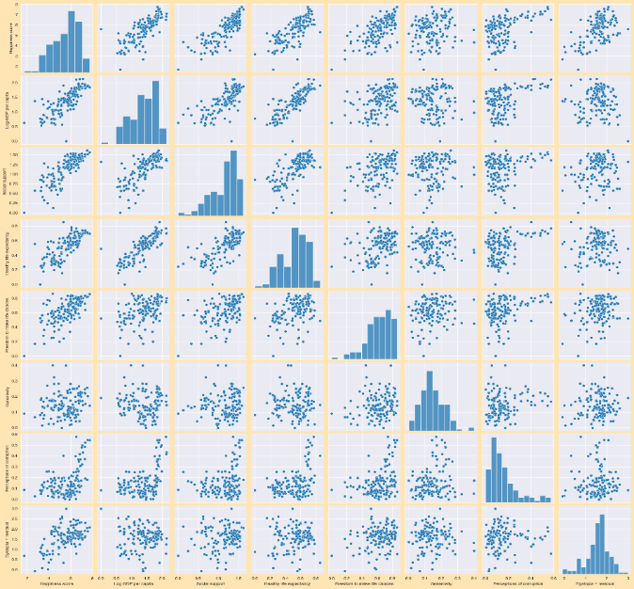

Figure 5: Pairplot

* Creates a scatter plot using Matplotlib to visualize the relationship between the " Healthy life expectancy” and "Log GDP per capita" columns from the DataFrame df.

plt.scatter() function is used to create a scatter plot.

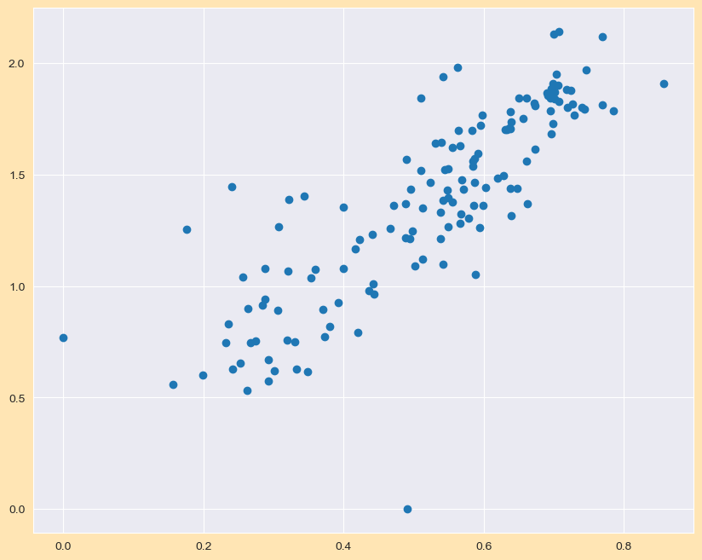

Figure 6: Sactterplot between Healthy life expectancy' and GDP

* The code df['Regional Indicator'].unique() retrieves the unique values present in the column named 'Regional Indicator' in the DataFrame df. This operation can help you understand the different categories or groups present in that column. Now calculate the total happiness score for each region by grouping the DataFrame df by the 'Regional Indicator' column and then summing the 'Happiness score' column within each group.

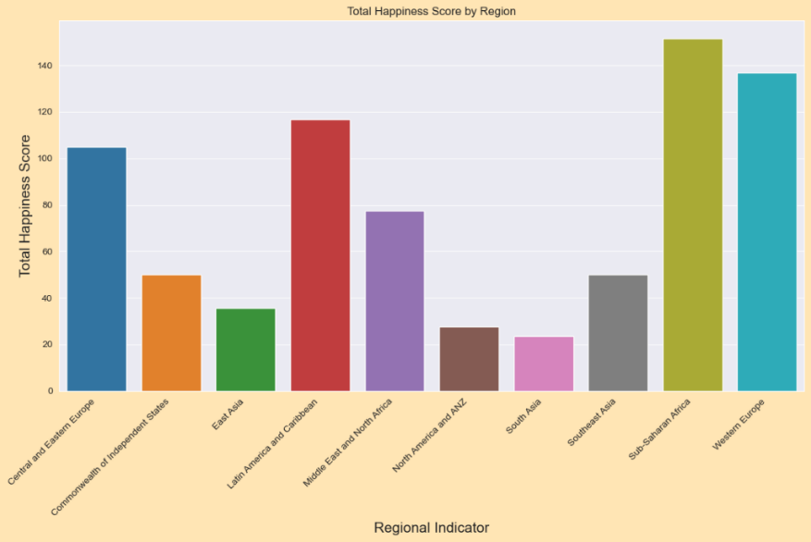

Figure 7: Total Happiness score by region

* Given below an interactive map that visualizes the happiness scores of various countries. The map is styled with the 'Viridis' color scale, and the happiness scores are displayed as a color gradient. The map is projected using an equirectangular projection and does not show the frame around the map. The interactive plot allows users to go over the countries to see their names and happiness scores.

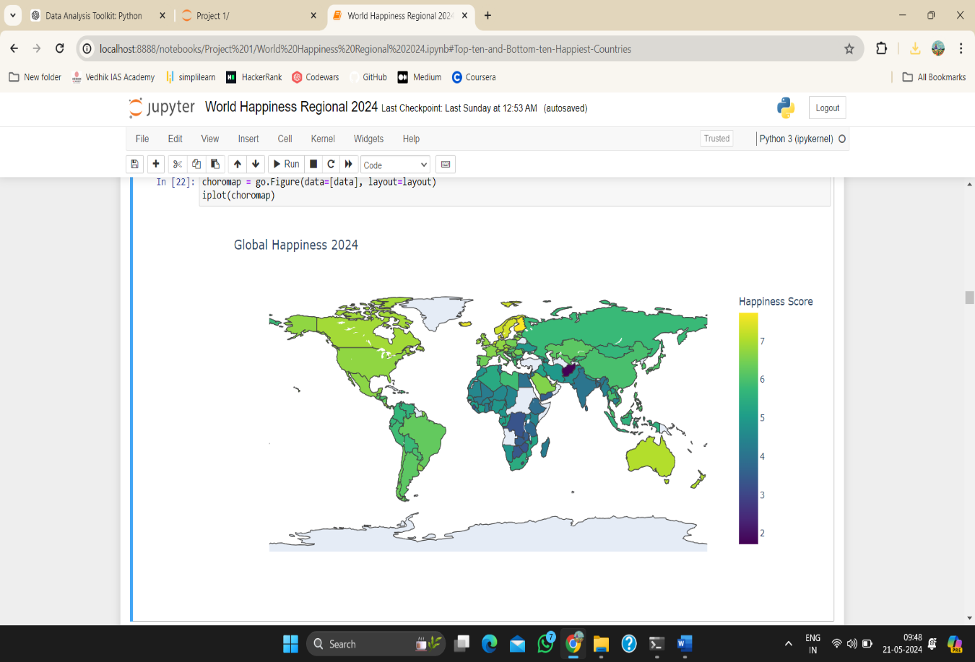

Figure 8: Regional Happiness score in a choropleth map

* This is a scatter plot with happiness score on the x-axis, GDP per capita on the y-axis, and regions represented by different colors. The plot will have a title, legend, and appropriately labeled axes.

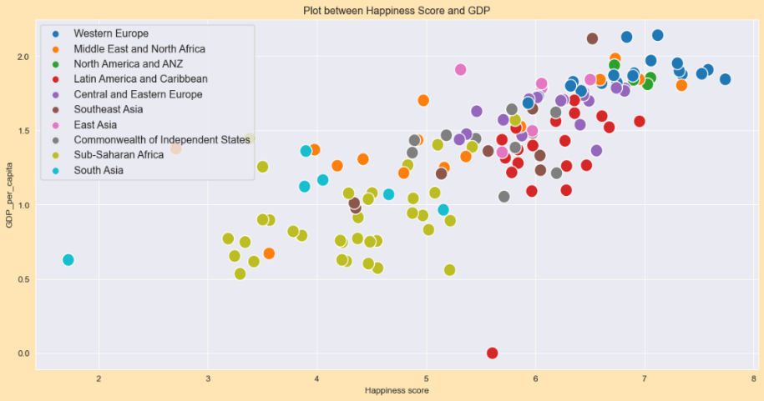

Figure 9: Plot between Happiness Score and GDP

* A regression plot with "Healthy life expectancy" on the x-axis and "Social support" on the y-axis, showing the trend between these two variables. The title and axis labels provide context for interpretation.

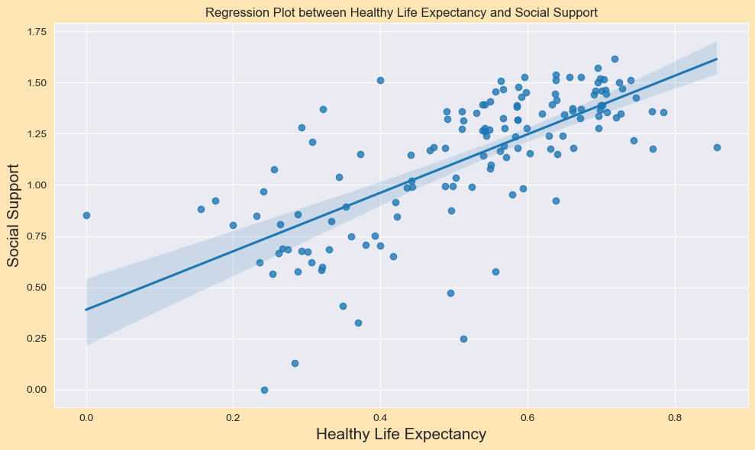

Figure 10: Regression Plot between Healthy Life Expectancy and Social Support

* A pie chart to visualize the distribution of GDP per capita across different regions. This information is useful for comparing the total GDP per capita across different regions. It provides insights into the economic status or development level of each region based on the sum of GDP per capita.

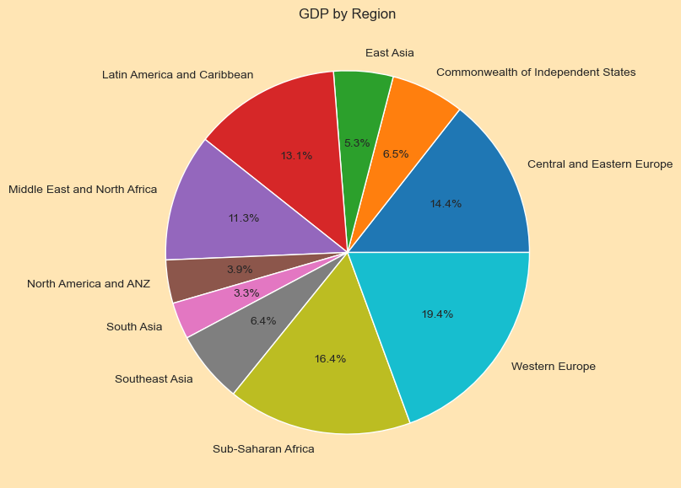

Figure 11: GDP by Region

* Calculated the total number of countries within each region by grouping the DataFrame df by the 'Regional Indicator' column and then counting the number of occurrences of 'Country name' within each group. Also calculated the median value of "Generosity" for each region, then creates a bar chart to visualize these median values.

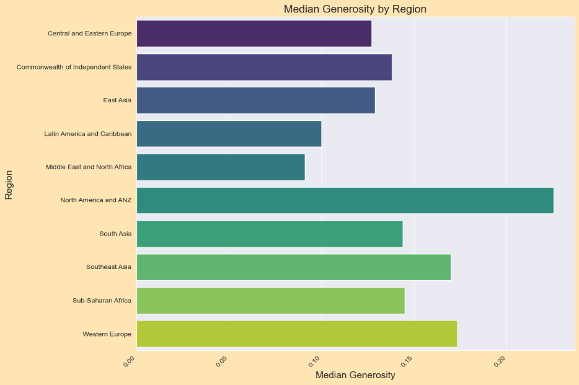

Figure 12: Median Generosity by Region

* The insights into the perceived level of corruption across different regions can be useful for understanding variations in corruption perceptions and comparing them between regions. This bar plot showing the perceived level of corruption in various regions. Each bar represents a region, and its height indicates the mean perception of corruption for that region.

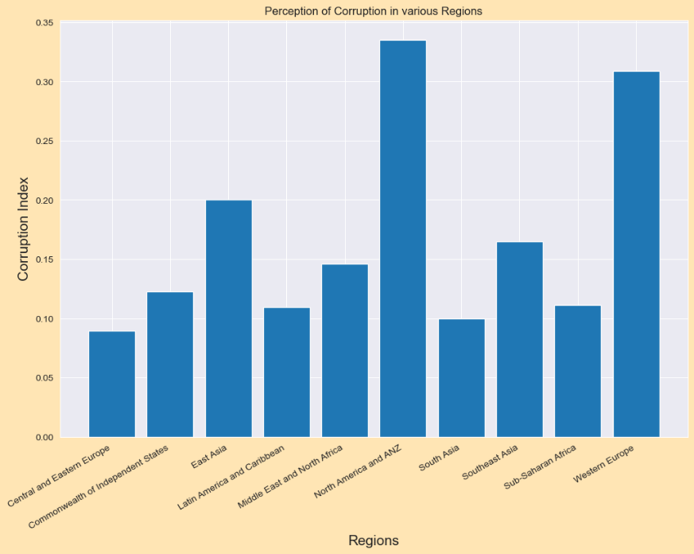

Figure 13: Perception of corruption by Region

* Scatter plot showing the relationship between happiness score and generosity, with different regions differentiated by color.

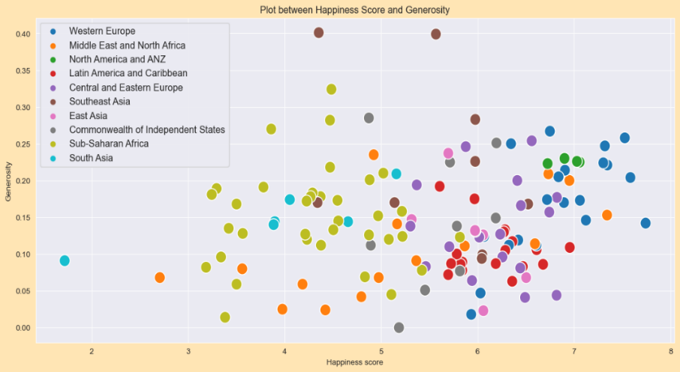

Figure 14: Happiness score and Generosity

* Created a side-by-side bar plot comparing the healthy life expectancy of the top 10 happiest countries and the bottom 10 least happy countries.

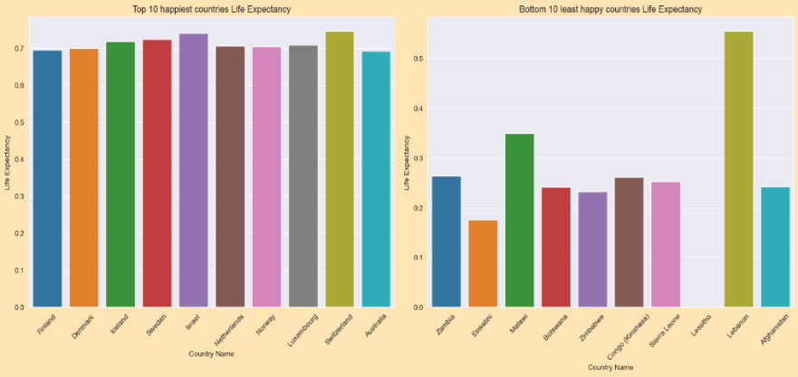

Figure 15: Top ten and Bottom ten Happiest Countries

* Given below the scatter plot to explore the relationship between "Freedom to Make Life Choices" and "Happiness Score", with regions represented by different colors.

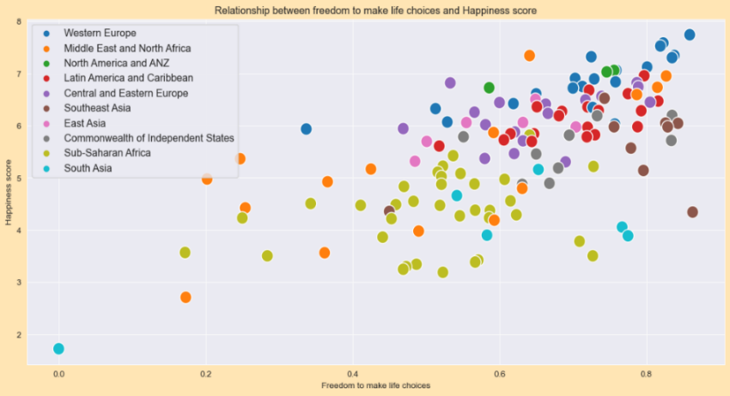

Figure 16: Happiness score vs. freedom to make life choices

* sns.heatmap(df.corr(),square=True)

Creates a heatmap using Seaborn to visualize the correlation matrix df.corr() computes the pairwise correlation of columns in the DataFrame df. This creates a correlation matrix where each cell represents the correlation coefficient between two variables.

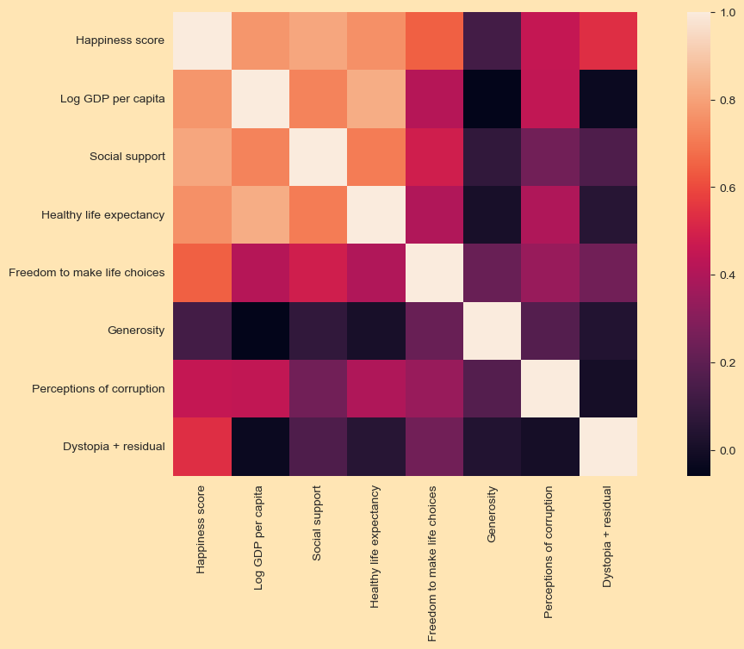

Figure 17: Correlation heatmap

4.5 Model Optimization

We will now use different regression algorithms to develop models to help predict the happiness score based on the independent variables. For this study, we use three algorithms for prediction, namely, Multiple Linear Regression and Polynomial Regression.

**4.5.1 Regression Analytics**

For the regression analysis, here used the Pandas, NumPy, Matplotlib Scikit-learn libraries. Next setting my target variable. The dataset is split into testing and training sets to develop each model. Following industry standards, 30% of the data is used for testing, with the remaining 70% allocated for training the algorithm. Data randomization ensures a diverse range for testing and training. The dataset is divided into training and test sets based on the Happiness score variable. This helps to define important labels and select the best-fit feature using multilayer perceptions as the model training method, utilizing backpropagation for training. Then we predict the model scores and then computes various evaluation metrics. Here given the scores and evaluation matrics in each model.

Regression models are essential tools in predicting continuous outcomes, like the happiness score in the World Happiness Report. Two common types of regression models used in this context are Multiple Linear Regression and Polynomial Regression. Both models allow us to understand the relationships between the happiness score and several influencing factors such as GDP per capita, social support, life expectancy, and others.

**Multiple Linear Regression:**

It is an extension of simple linear regression where more than one independent variable is used to predict the dependent variable (happiness score). The model assumes a linear relationship between the dependent and independent variables.

* **Independent Variables (Predictors):** Factors that might influence the happiness score, such as GDP per capita, social support, etc.
* **Dependent Variable (Response):** The outcome we want to predict, which is the happiness score.
* **Coefficients:** These represent the change in the happiness score for a one-unit change in the corresponding independent variable, holding other variables constant.

Multiple linear regression involves predicting a dependent variable using multiple independent variables.

Steps:

* Import necessary libraries
* Load and preprocess the data
* Split the data into training and testing sets
* Train the multiple linear regression model
* Evaluate the model
* Visualize the results

The Accuracy score and evaluation matrics using this model for our data is given;

Linear Regression Evaluation Metrics:

Mean Squared Error (MSE): 0.23626644918328543

Root Mean Squared Error (RMSE): 0.48607247317996255

Mean Absolute Error (MAE): 0.3930800783861078

R-squared (R2): 0.8415170810759418

Adjusted R-squared: 0.8143485806889604

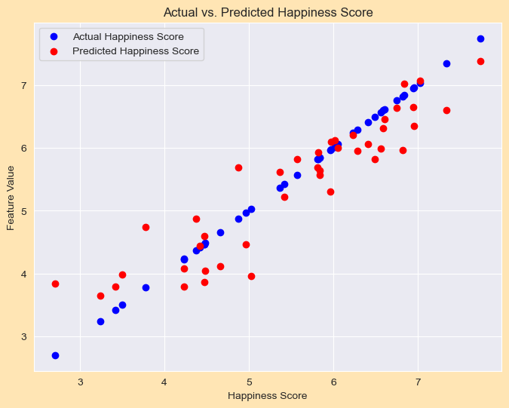

Figure 18: Actual vs. Predicted happiness Score

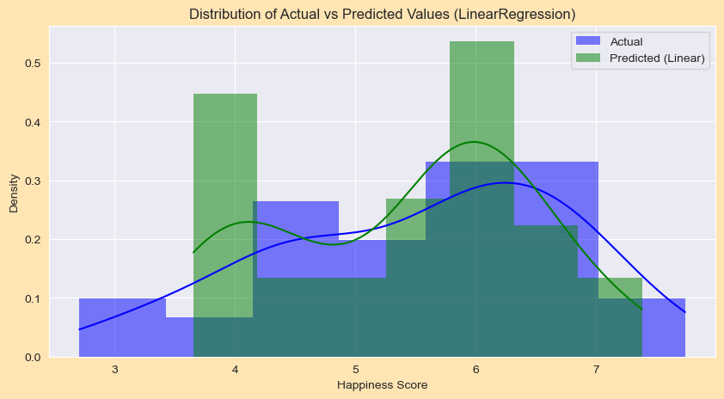

Figure 19: Distribution plot of Actual vs. Predicted value in multiple regression

**Polynomial Regression:**

**It**is a type of regression where the relationship between the independent variables and the dependent variable is modelled as an nth degree polynomial. It can model non-linear relationships between the features and the outcome, which makes it more flexible than linear regression. Polynomial regression involves fitting a polynomial equation to the data.

Steps:

* Import necessary libraries
* Load and preprocess the data
* Transform features to polynomial features
* Split the data into training and testing sets
* Train the polynomial regression model
* Evaluate the model
* Visualize the results

Polynomial Regression Evaluation Metrics:

Mean Squared Error (MSE): 0.40409183085123684

Root Mean Squared Error (RMSE): 0.6356821775472684

Mean Absolute Error (MAE): 0.4753370535714285

R-squared (R2): 0.7289430933251551

Adjusted R-squared: 0.6824761950380388

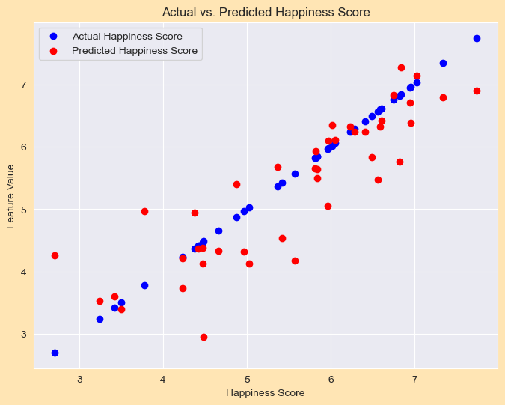

Figure 20: Scatter plot Actual vs. Predicted happiness Score

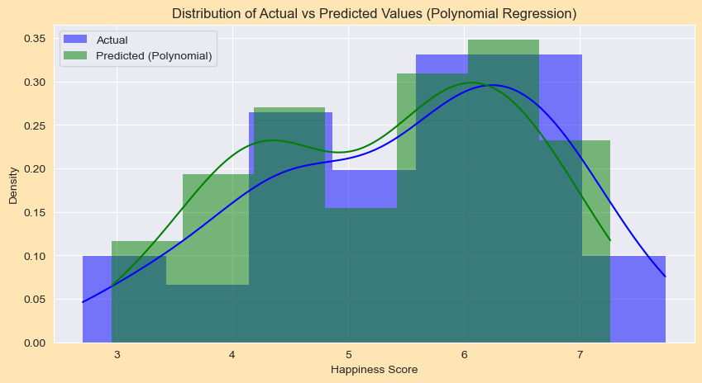

Figure 21: Distribution plot of Actual vs. Predicted happiness Score

4.6 Model Evaluation and Selection

The evaluation metrics that we have used for our models are:

MSE, RMSE, MAE, R-Squared and Adjusted R-Square Value.

**MSE**: Mean Squared Error is the difference in the average values between the actual values and the predicted and the square of that. (By calculating MSE we are getting the average length of all the residuals to capture the error in this model)

**RMSE**: It is the square root of the MSE. RMSE gives a larger weightage to bigger errors and thus RMSE helps indicate larger errors and outliers in a more proficient way.

**MAE**: Mean Absolute Error measure the accuracy of a model. it measures how far the predictions are from the actual values on average.

**R-Squared Value**: This value shows the amount of variance that can be explained by the model between predicted values and expected values[53]. R² values range from 0 to 1, with higher values indicating better model fit.

**Adjusted R-squared:** Adjusted R² adjusts the R² value based on the number of predictors in the model, penalizing the addition of irrelevant predictors. Adjusted R² is more accurate than R² for models with multiple predictors. It provides a more reliable measure of how well the model explains the variability of the dependent variable while taking into account the number of predictors or the complexity of the polynomial. This helps in avoiding overfitting and ensures that the model is as simple as possible while still being effective.

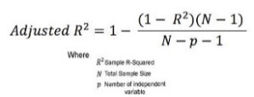

|  |  |  |  |  |  |
| --- | --- | --- | --- | --- | --- |
| **Model** | **MSE value** | **RMSE value** | **MAE value** | **R-Squared value** | **Adjusted R-square Value** |
| Multiple Linear Regression | 0.2362664 | 0.4860724 | 0.3930800 | 0.8415170 | 0.8143485 |
| Polynomial Regression | 0.4040918 | 0.6356821 | 0.4753370 | 0.7289430 | 0.6824761 |

Table 1: Comparison of the different Regression Algorithms

Below, you will find insights from regression analytics on the model developed in the table. The columns display the evaluation results of each model in terms of the explained variance and the errors generated by them. A model with low MSE, RMSE, and MAE, along with a high R² and Adjusted R², is considered to have good predictive performance.

**Select best model:**

The “Multiple Linear Regression” model performs better overall than the polynomial regression model, as evidenced by its higher R², lower MSE, RMSE, and MAE values.

Chapter 5: Results and discussion

Thus, through our experimental analysis, we can see that Multiple Linear regression is the best predictor, followed by Polynomial Regression.

|  |  |
| --- | --- |
| Model names | R-squared (R²) Value |
| Multiple Linear Regression  Polynomial Regression | 0.8415170810759418  0.7289430933251551 |

Table 2: R² Value of the utilized methods.

**Multiple Linear Regression:**

Linear Regression Evaluation Metrics:

Mean Squared Error (MSE): 0.23626644918328543

Root Mean Squared Error (RMSE): 0.48607247317996255

Mean Absolute Error (MAE): 0.3930800783861078

R-squared (R2): 0.8415170810759418

Adjusted R-squared: 0.8143485806889604

**Mean Squared Error (MSE):** The MSE, which measures the average of the squares of the errors between actual and predicted values, is approximately 0.2363. This metric indicates the average magnitude of errors in the model's predictions. A lower MSE value suggests better accuracy, and the obtained value indicates relatively small errors overall.

**Root Mean Squared Error (RMSE):** The RMSE, calculated as the square root of the MSE, is approximately 0.4861. It represents the standard deviation of the residuals (errors) and provides a measure of the model's performance in predicting the target variable. The obtained RMSE value indicates that, on average, the model's predictions are within approximately 0.4861 units of the actual values.

**Mean Absolute Error (MAE):** The MAE, which measures the average absolute errors between actual and predicted values, is approximately 0.3931. It represents the average magnitude of errors in the model's predictions, regardless of their direction. The obtained MAE value indicates that, on average, the model's predictions are approximately 0.3931 units off from the actual values.

**R-squared value (R²):** R-squared (R²) is a measure of how well the regression model explains the variability in the target variable, i.e. R² represents the proportion of the variance in the dependent variable (happiness score) that is predictable from the independent variables. The R² value of approximately 0.8415 indicates that the model explains about 84.15% of the variance in the target variable. Higher R² values suggest better model fit to the data.

**Adjusted R-squared:** The adjusted R² 0.8143 is slightly lower than the R², which is expected. It still indicates a good model fit, especially considering the number of predictors.

In conclusion, the Multiple Linear regression model appears to perform well based on the provided evaluation metrics. It demonstrates a high degree of explanatory power (as evidenced by the high R-squared score) and achieves relatively low error metrics (MSE, RMSE, and MAE), indicating good accuracy in predicting the happiness scores.

Chapter 6: Conclusion

This paper highlights the different trends that the factors of Happiness score have towards the happiness of the citizens in a country. We performed regression analysis on the dataset and evaluated the different models developed with evaluation and performance metrics.

Finland has a pretty high value for Log GDP per capita, Social Support, Healthy Life Expectancy and Freedom to Make Life Choices when compared to the maximum. It has a fairly low score for Perceptions of Corruption when compared to the minimum. Finland retained the greatest level of happiness, with an average score of 7.741, while Afghanistan was found to be the most unhappy. Out of 143 countries surveyed, India is ranked 126th, the same as last year.

As we discussed in the objective section through this project, we can explore the data through ML techniques to calculate world happiness scores. Got understanding of the six parameters affecting a happiness of the people in a country, and derived the vital inquiries from the data like; world happiness score relies on the economy GDP per capita, Health life expectancy led to happy life, and find correlation between all the variables. By exploratory data analysis we found that the dataset has no null values that make it less problematic, dropped the unnecessary columns, and done data cleaning and data preprocessing before data analysis.

The dataset is split into training set and testing set by a ratio of 70% and 30%. Various supervised learning regression algorithms have been used to evaluate the best performing model. Evaluation matrices used for model evaluation and model selection. The Multiple Linear regression model performs reasonably well in predicting the happiness score based on the selected features. Multiple Linear model's performance metrics indicate an R-squared score of 0.8415, the model explains a significant portion of the variance in the target variable. The high Score Accuracy Rate and Adjusted R-squared suggest that the model explains a substantial proportion of the variance in happiness scores indicating that adding polynomial terms did not improve the model’s performance and may have even introduced unnecessary complexity, leading to overfitting. Overall, these metrics collectively demonstrate that Multiple Linear regression model is well-fitted and performs effectively in predicting happiness scores. Additionally, the MSE, RMSE and MAE values are relatively low, indicating that the model's predictions are close to the actual values on average.

Data visualization helps in easy understanding and interpretation of the data. The heatmap effectively identifies and highlights the key variables that contribute most to the happiness score, guiding both analysis and potential policy interventions Log GDP per capita, social support, Healthy life expectancy, and Freedom to make life choices are the most influential factors on the happiness score as indicated by their strong positive correlations. Generosity and Perceptions of corruption have a much weaker correlation with the happiness score, suggesting that while they may play a role, their impact is less significant compared to the primary factors. Plotted region wise scatterplots, bar plots, for future reference and for better prediction.

Efforts to improve national happiness could focus on enhancing economic conditions (GDP per capita), improving social support systems, increasing life expectancy through healthcare improvements, and ensuring freedom for individuals to make life choices. Embrace happiness, for it's the beacon that lights our way to brighter tomorrows.

Chapter 7: Appendix

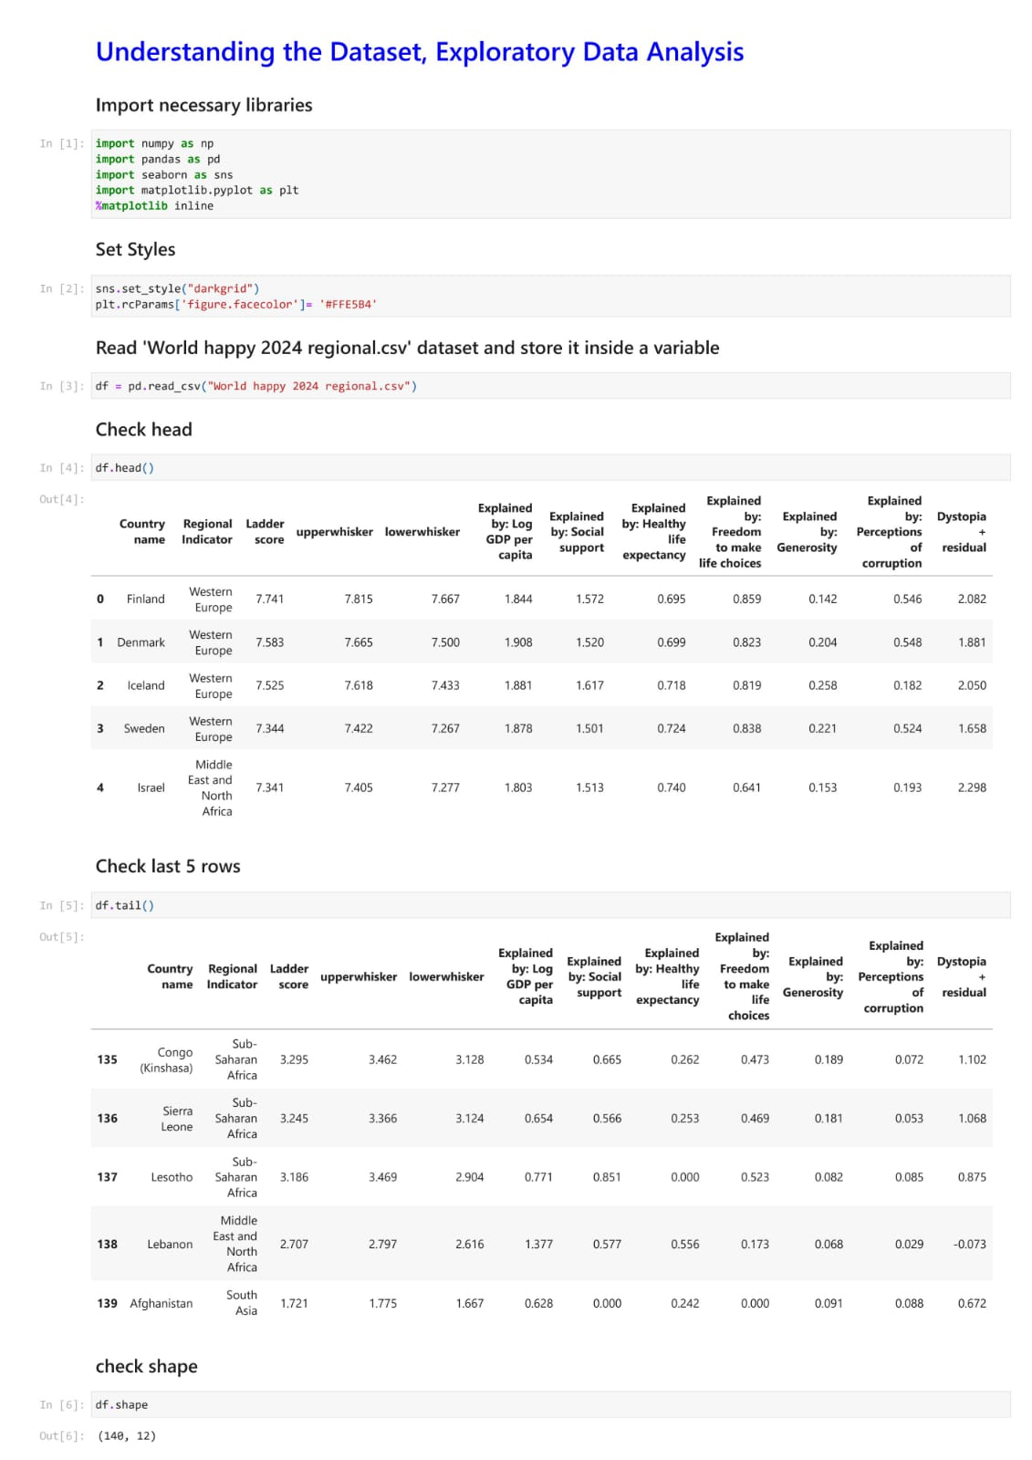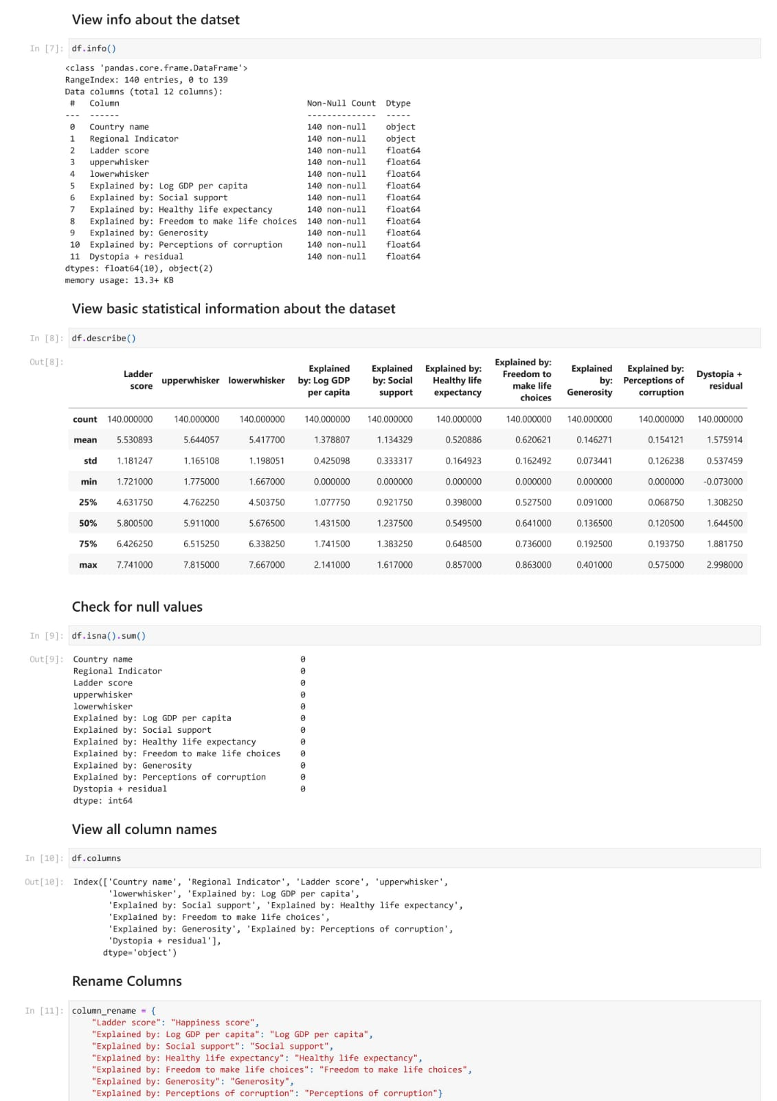

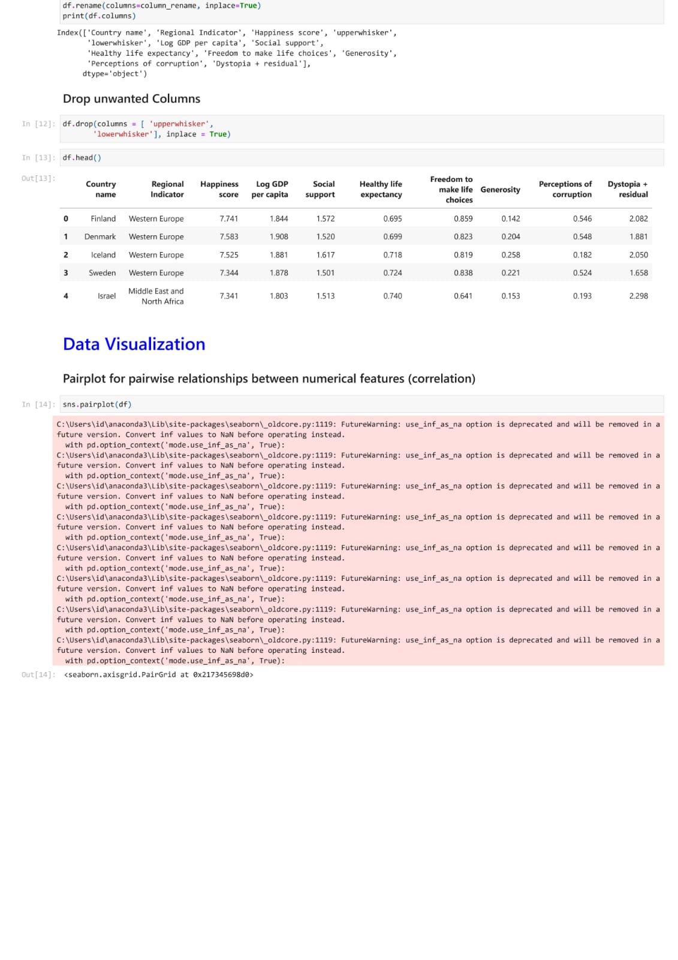

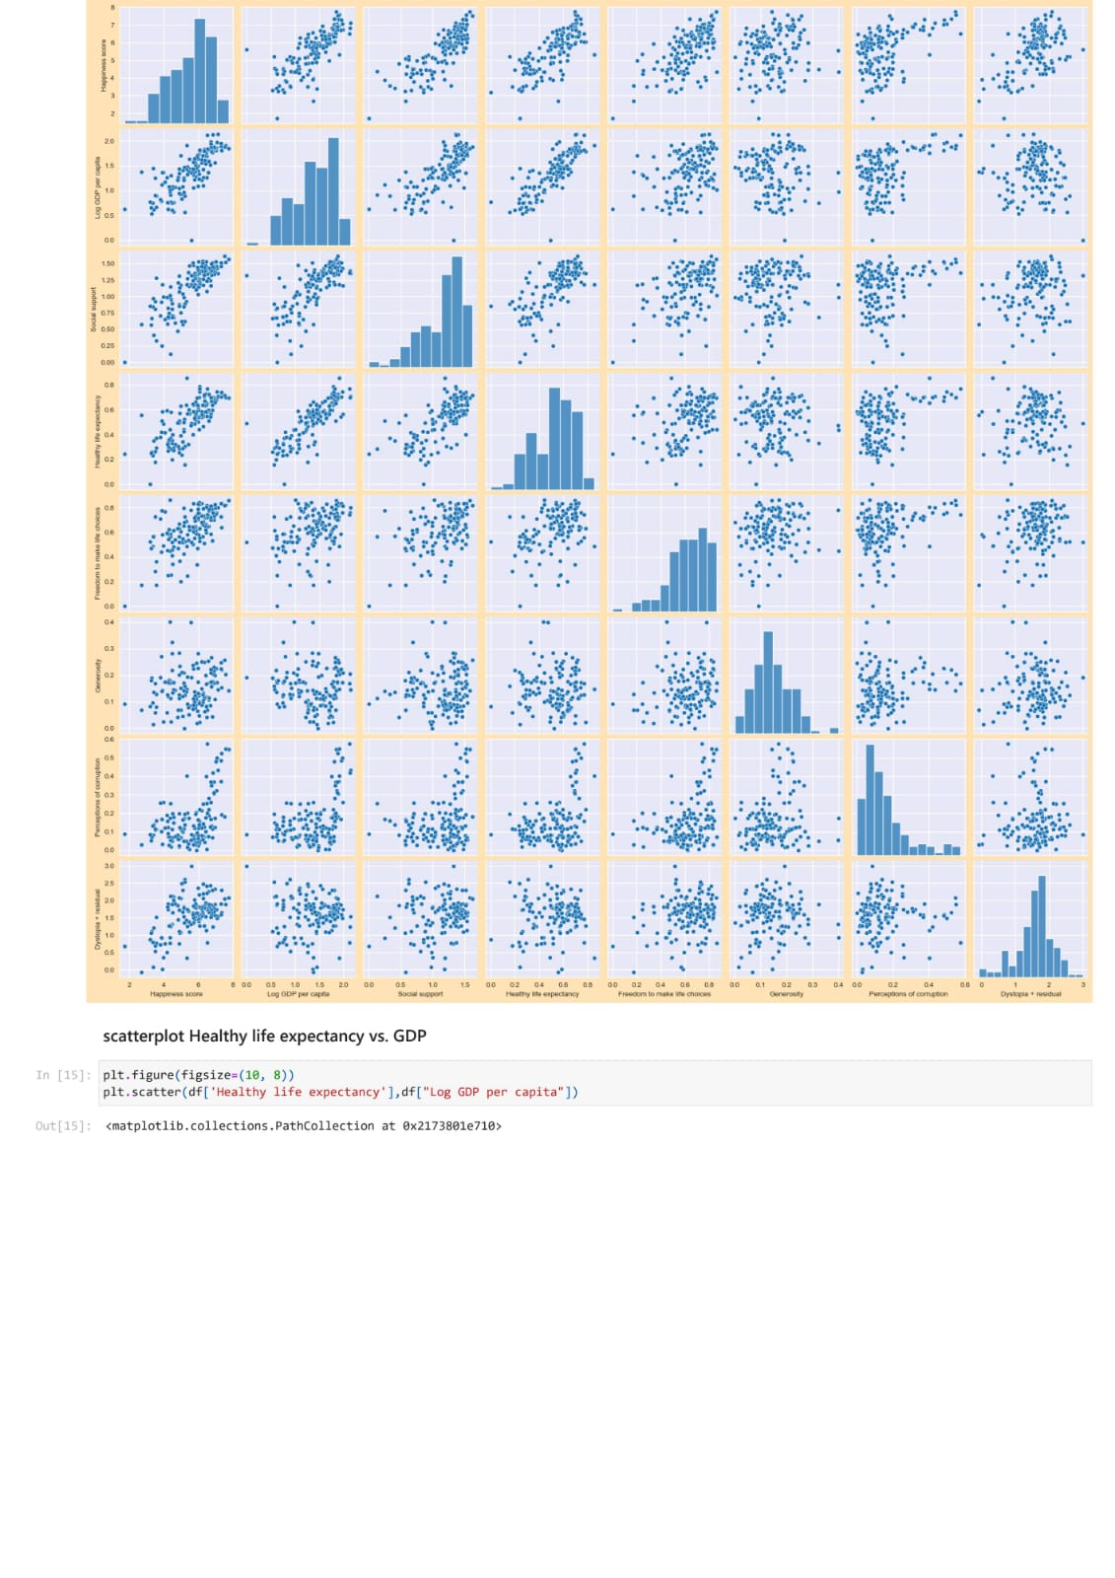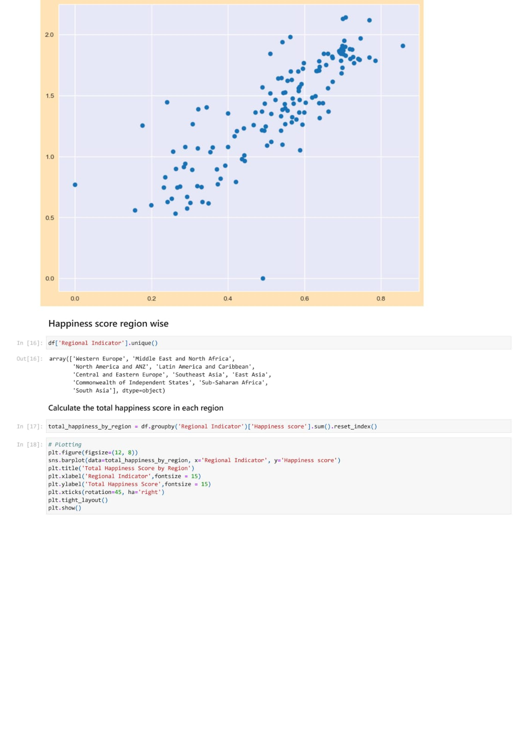

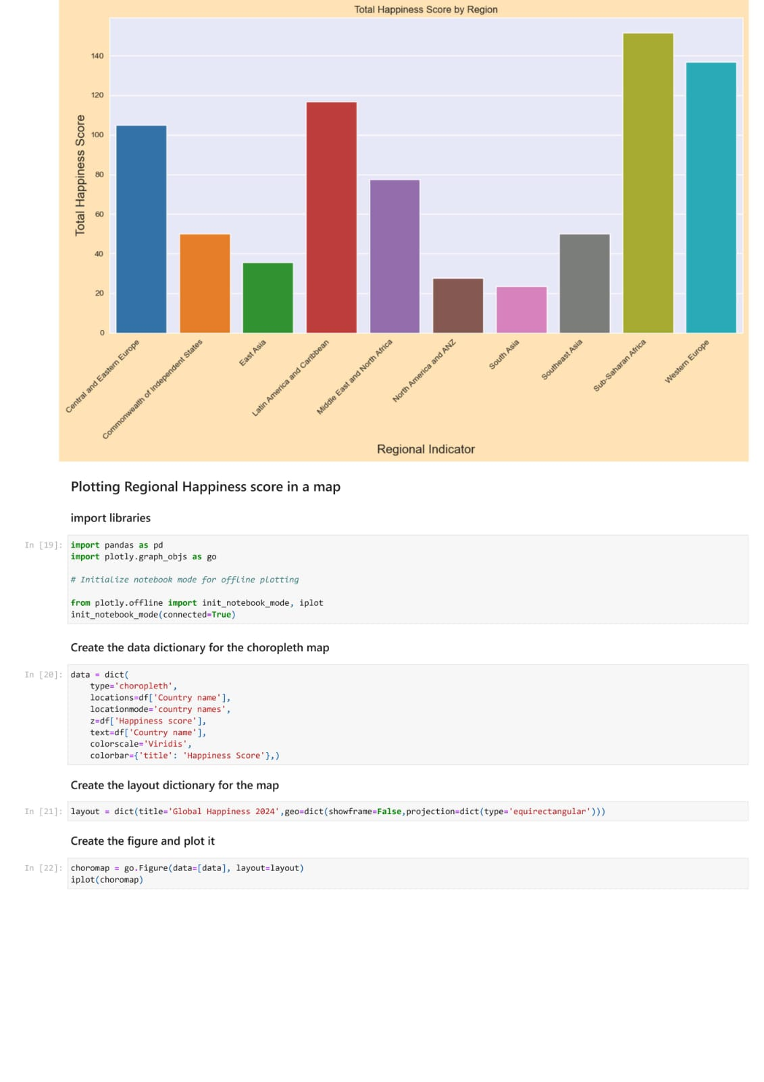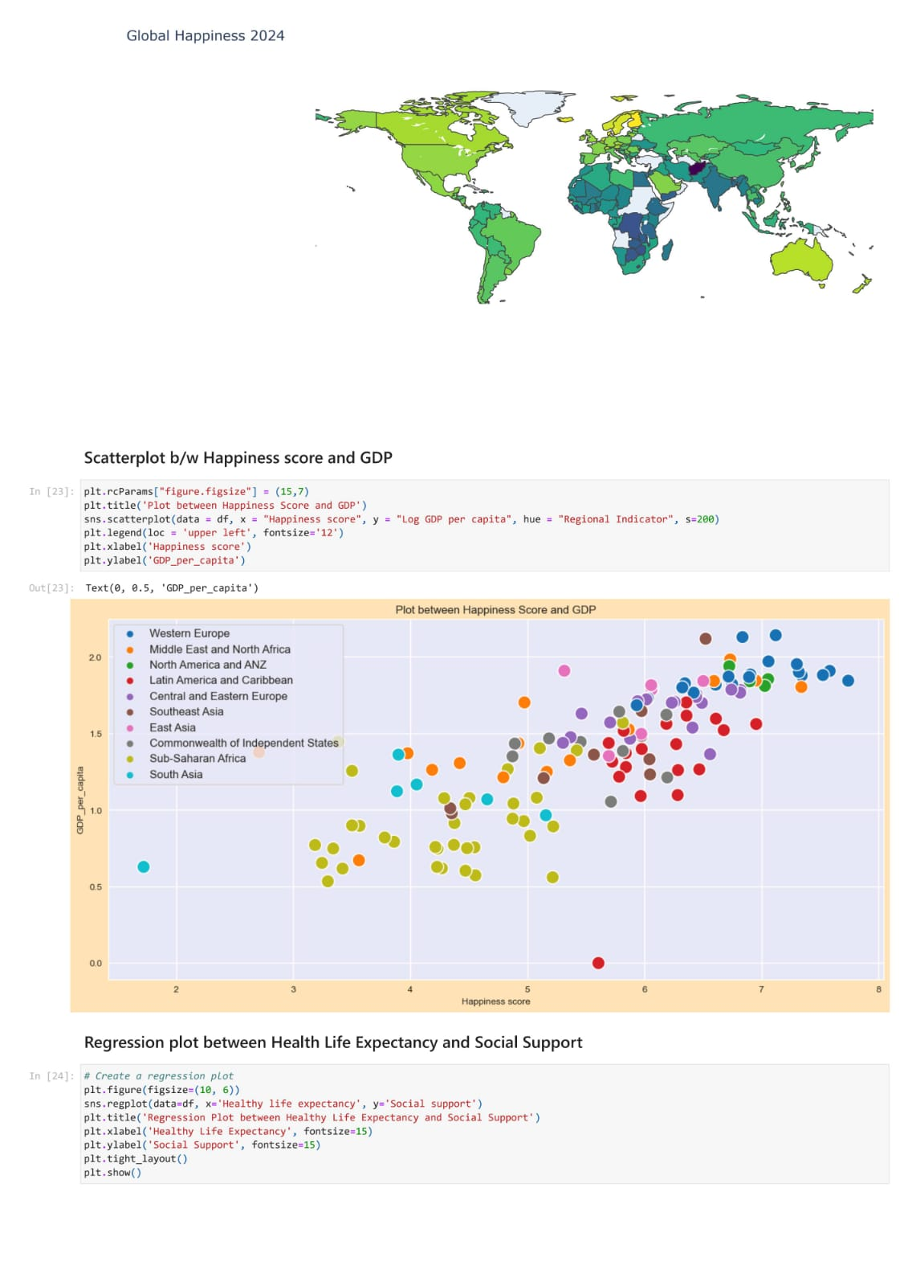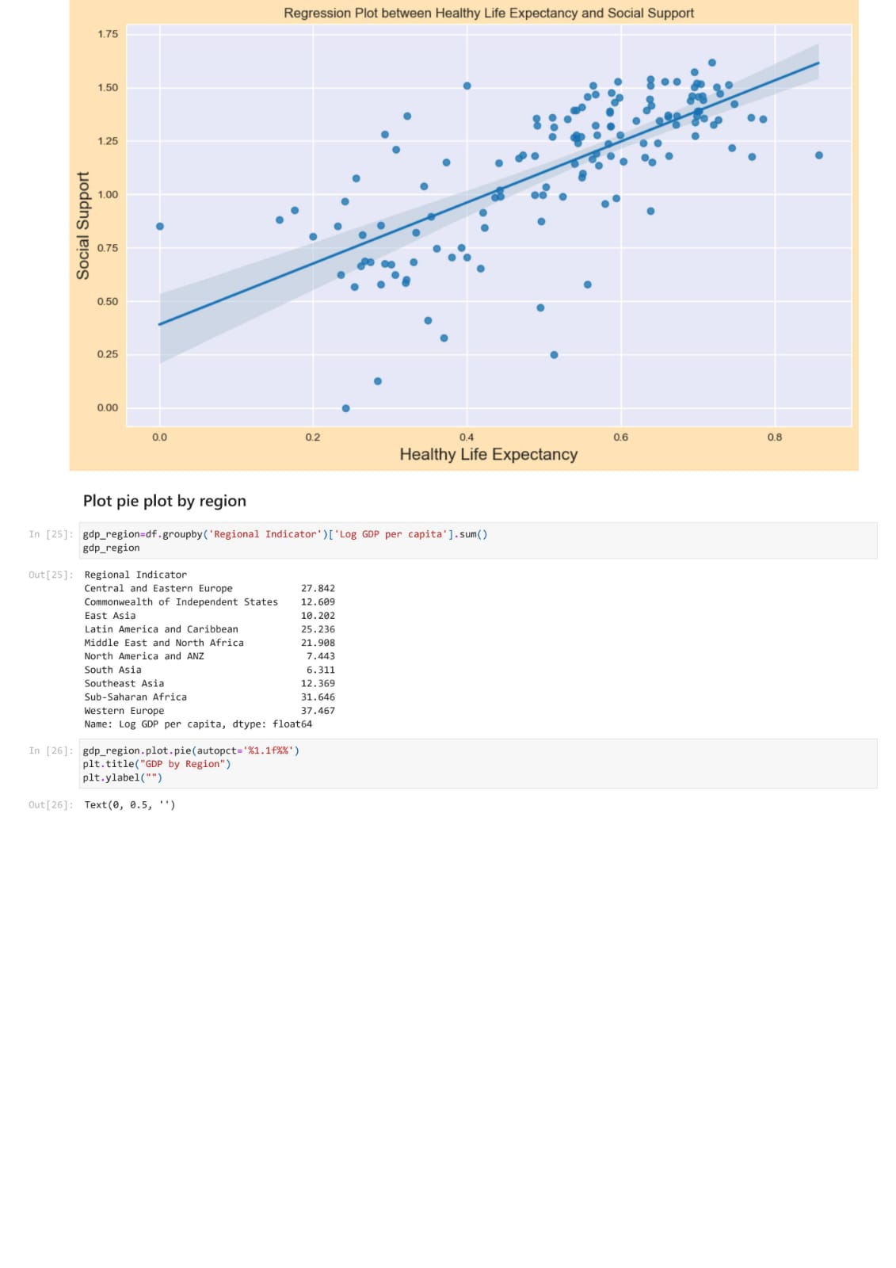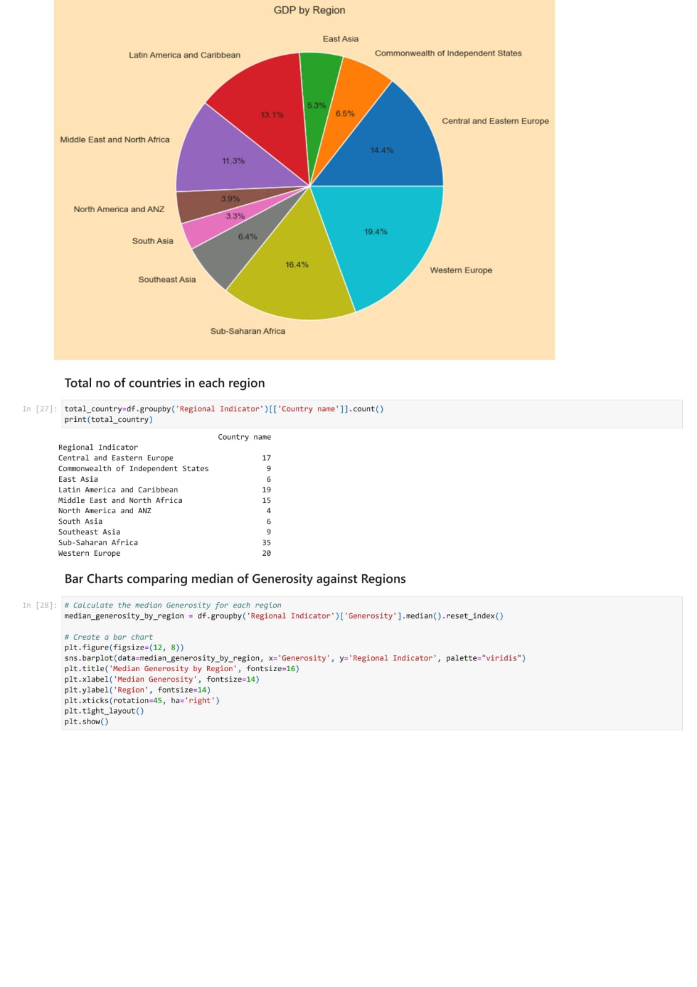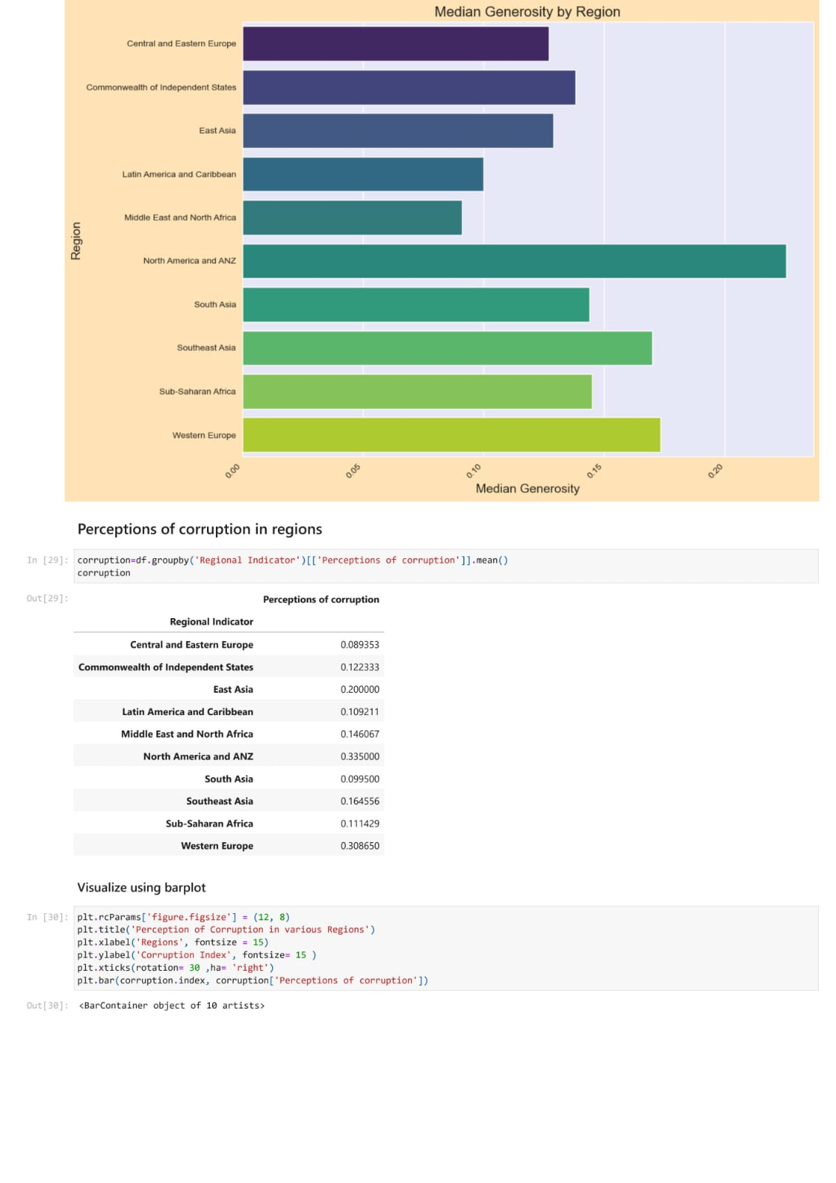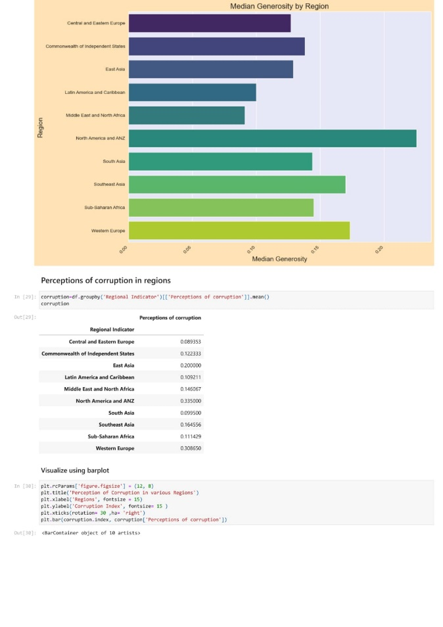 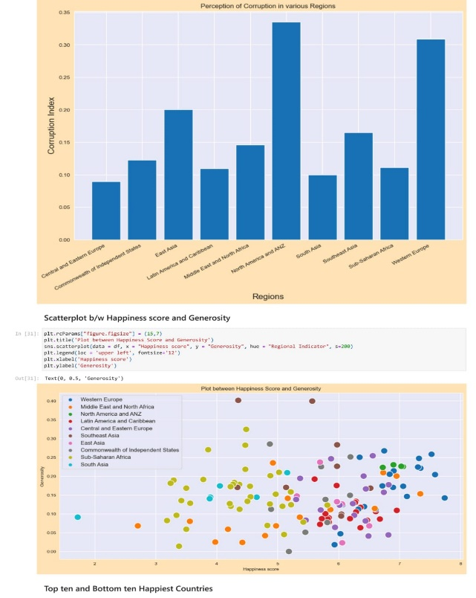

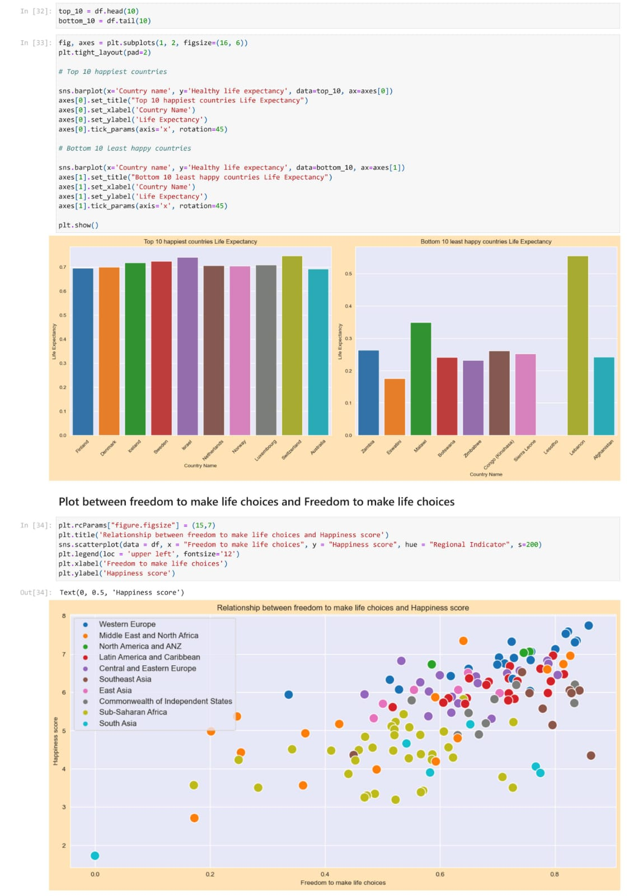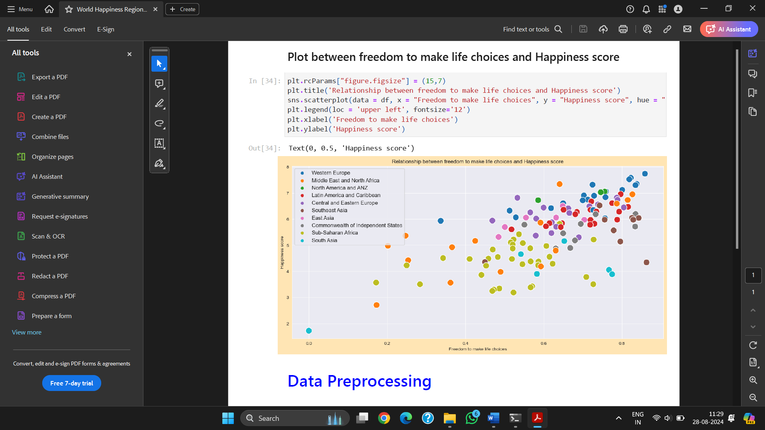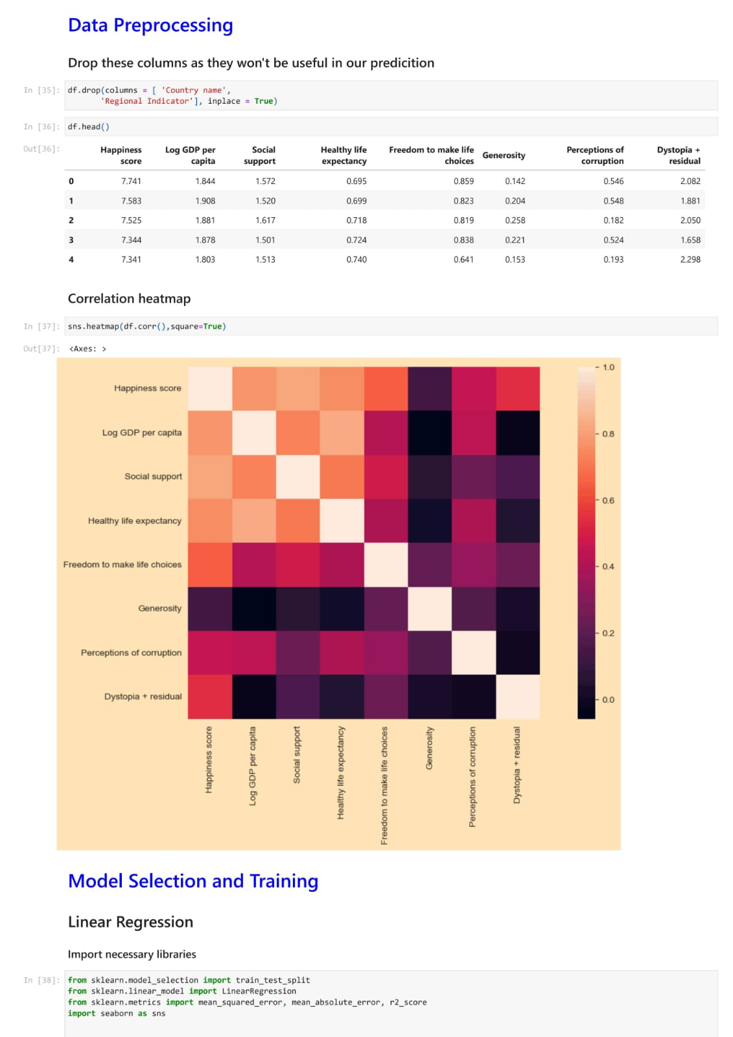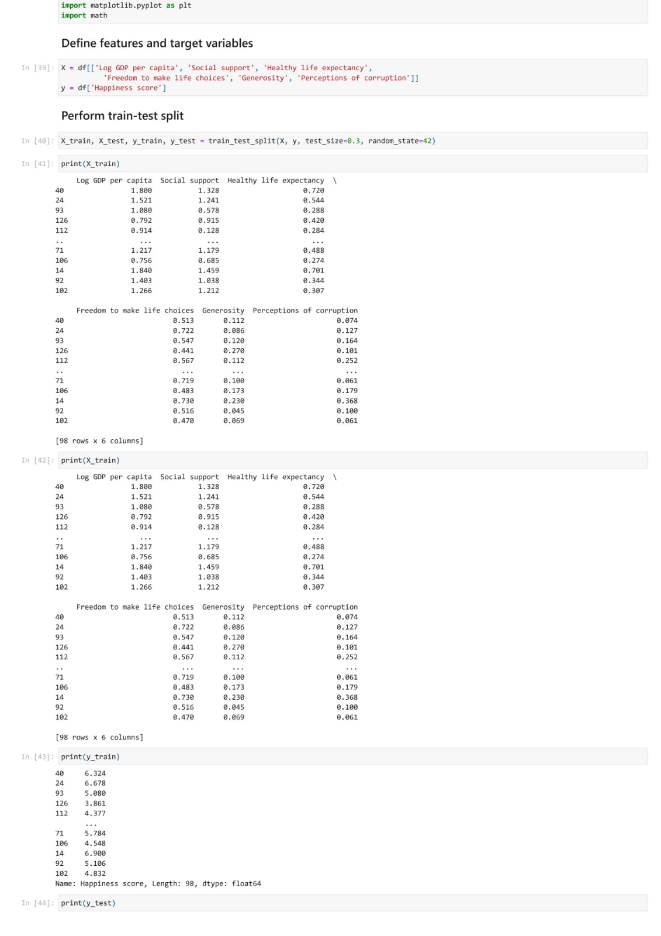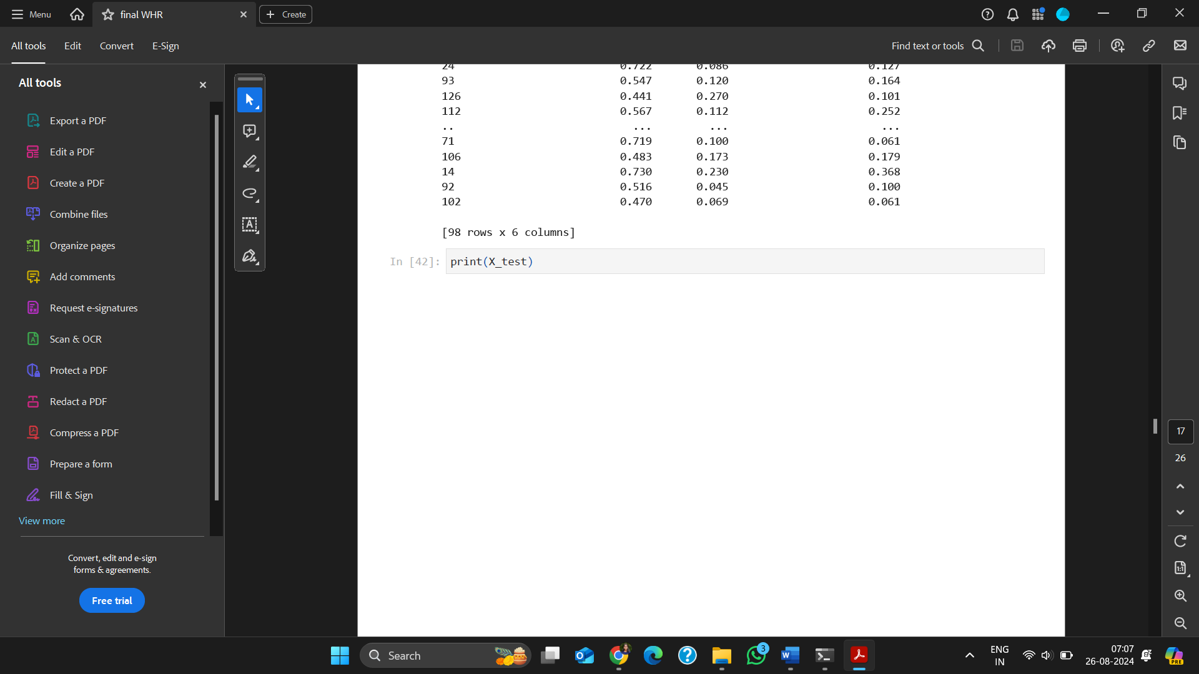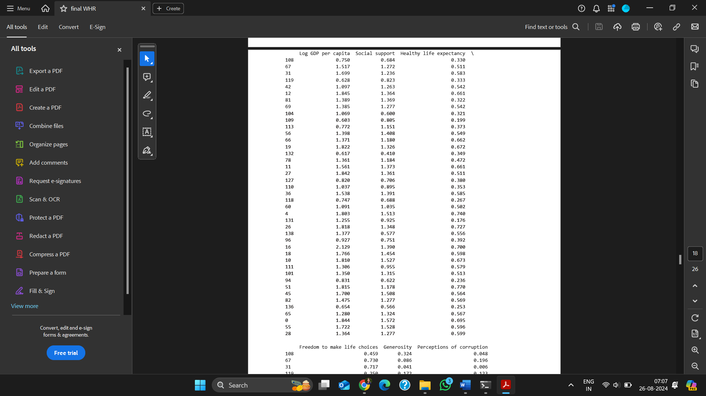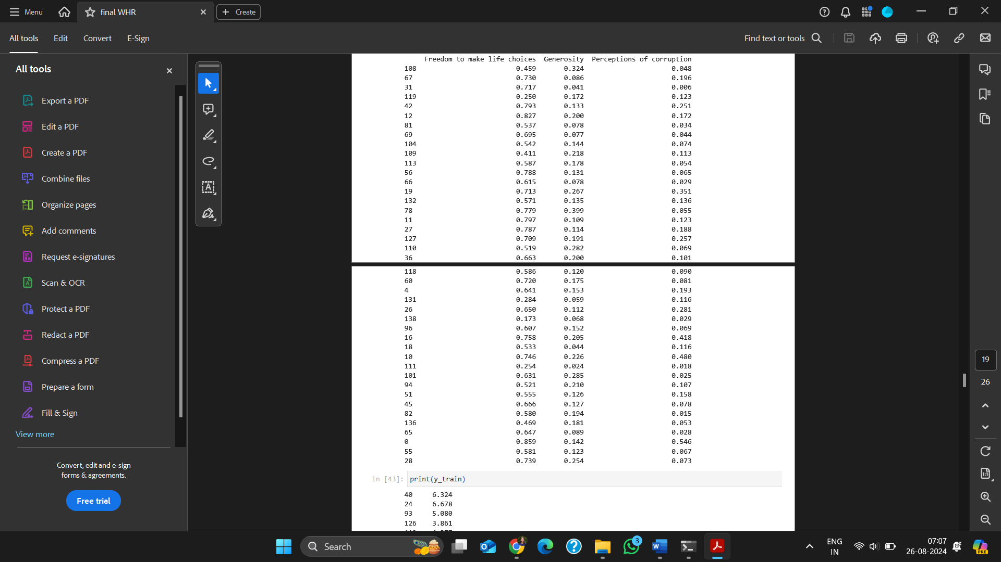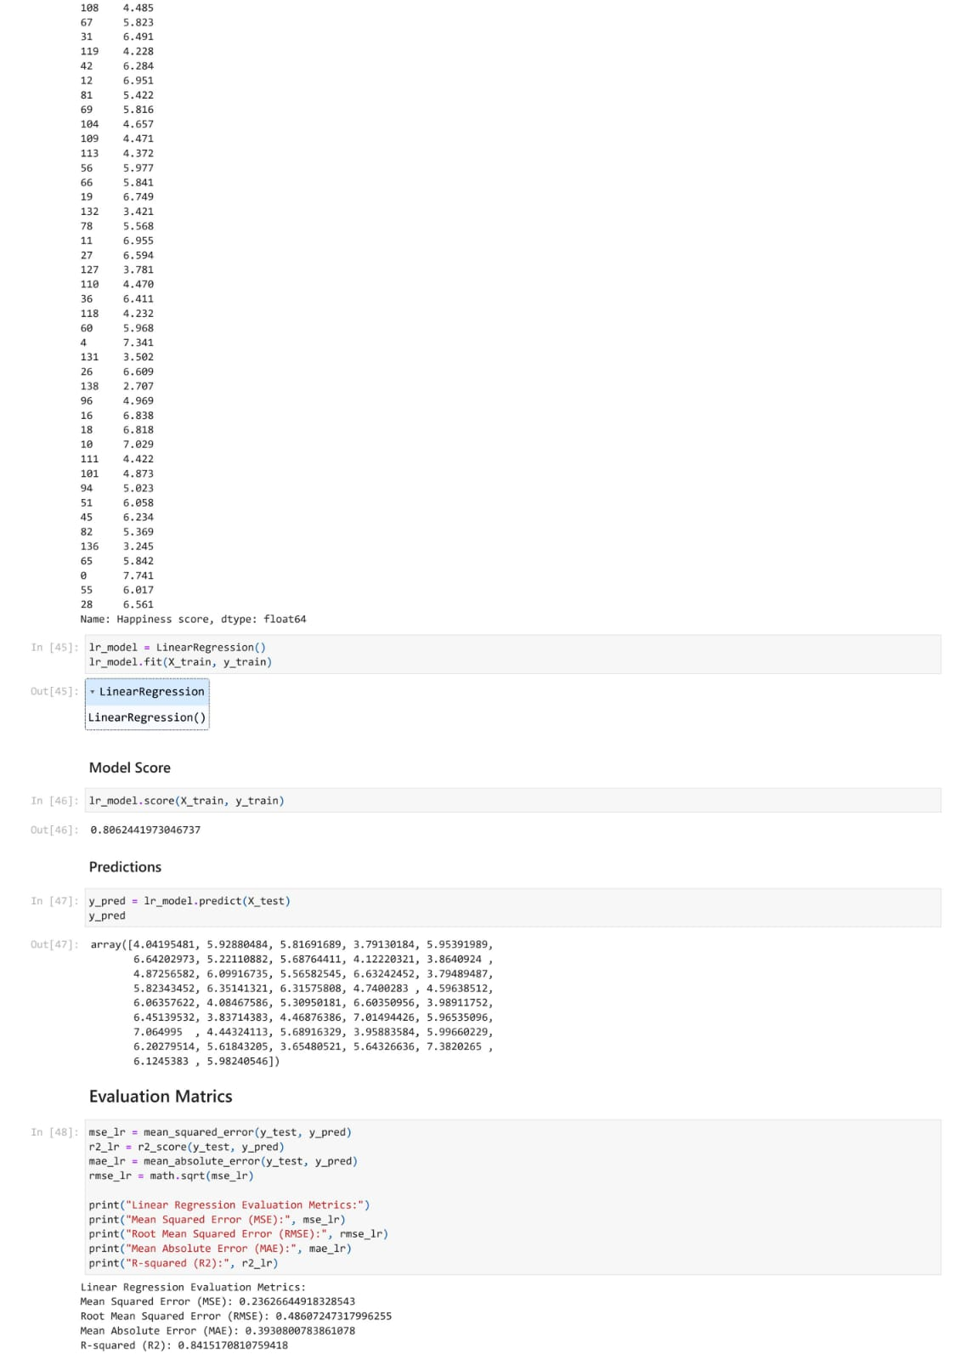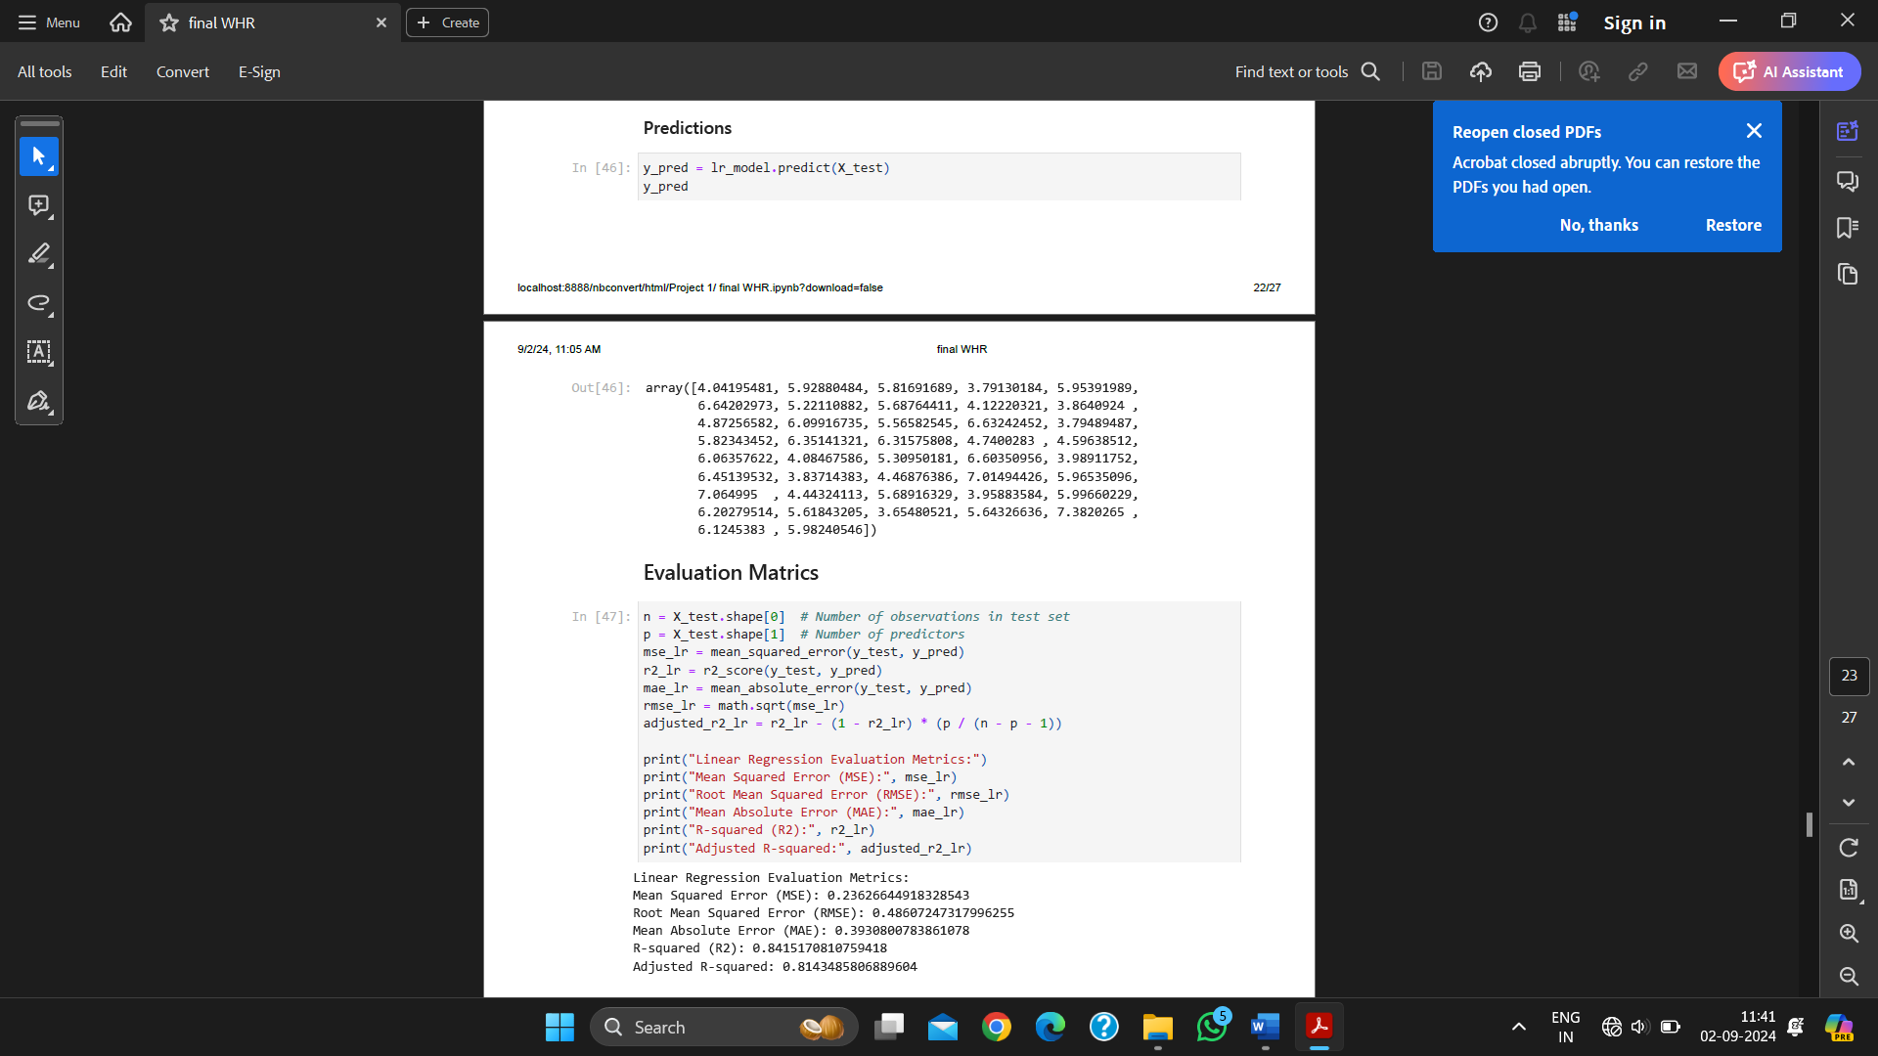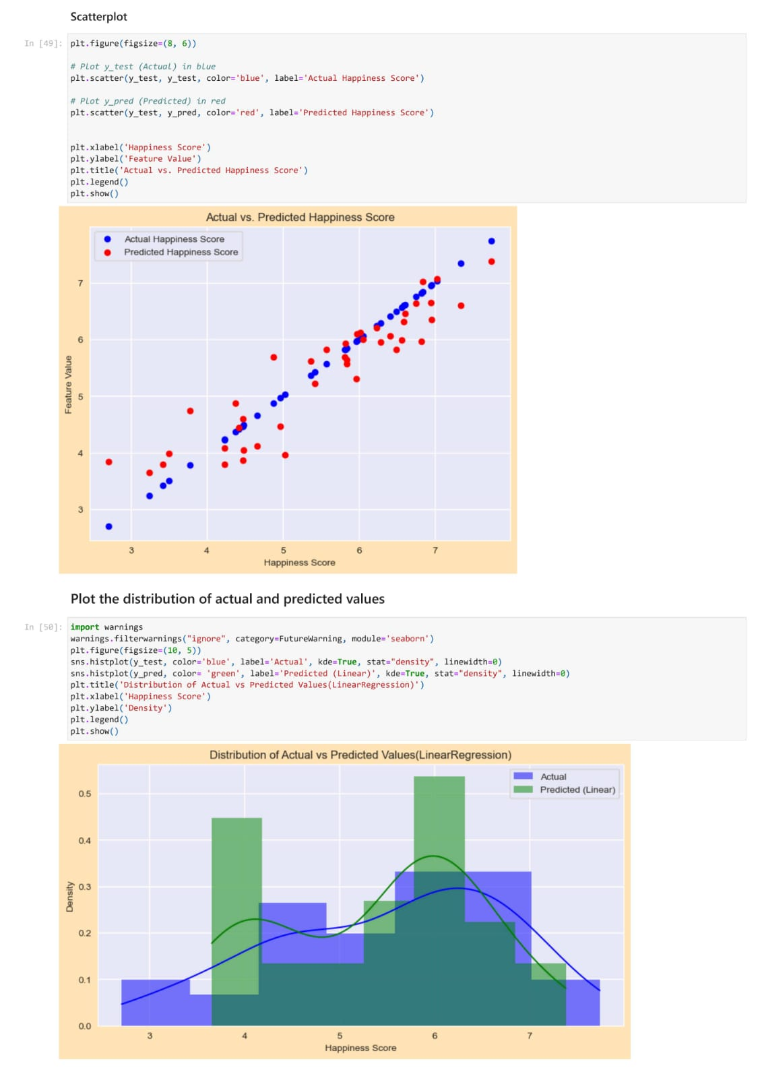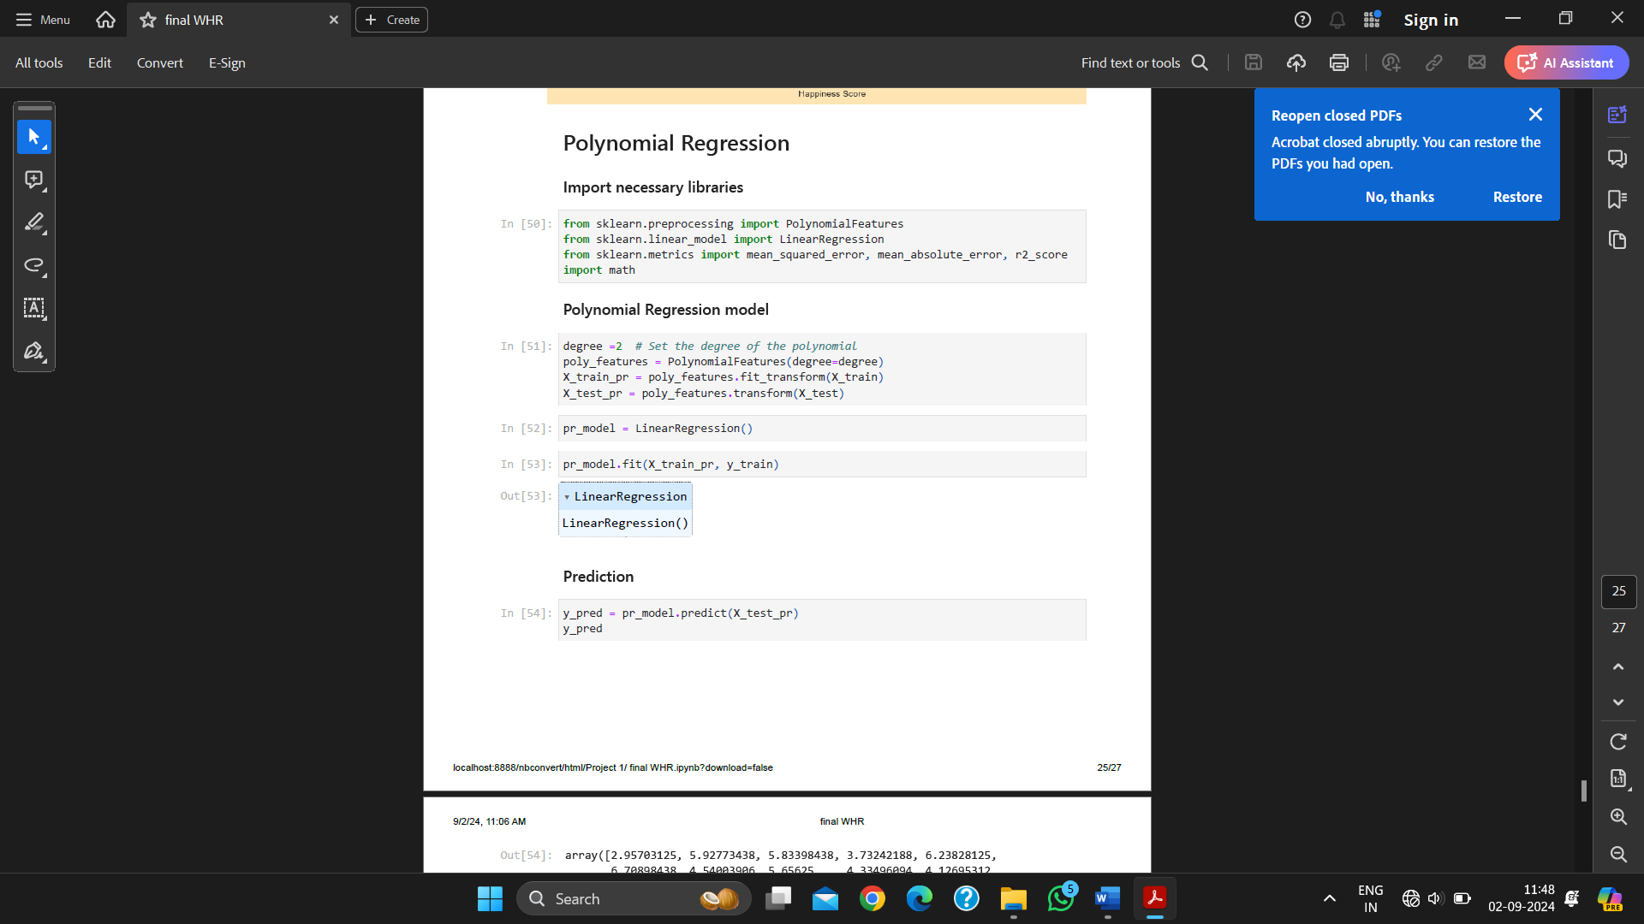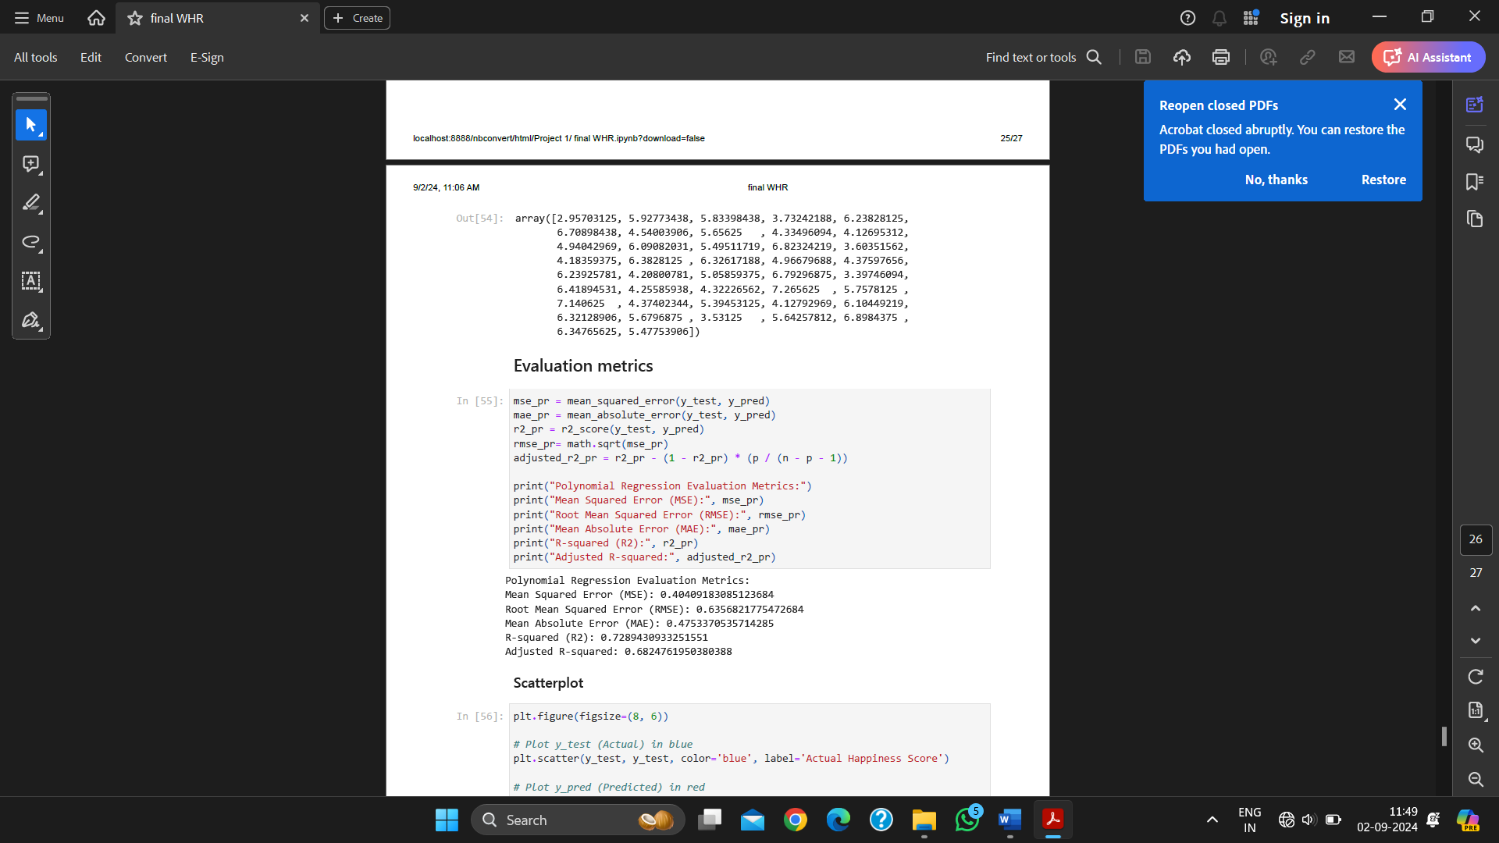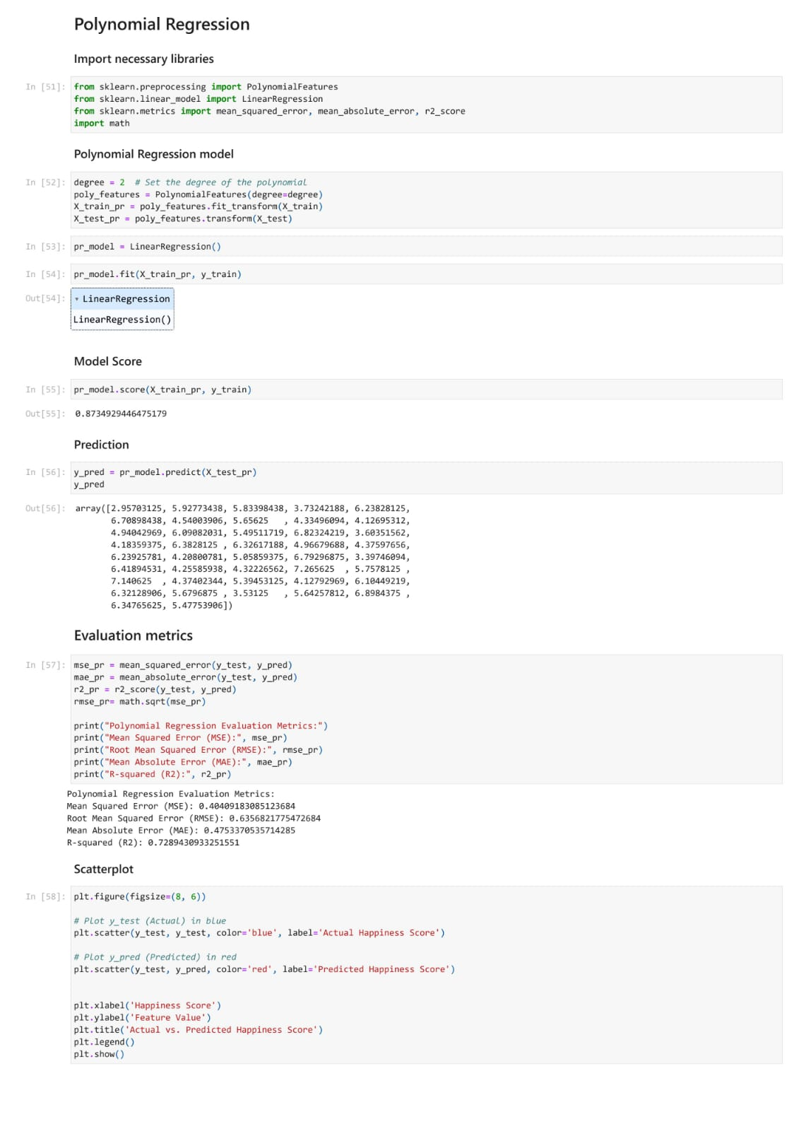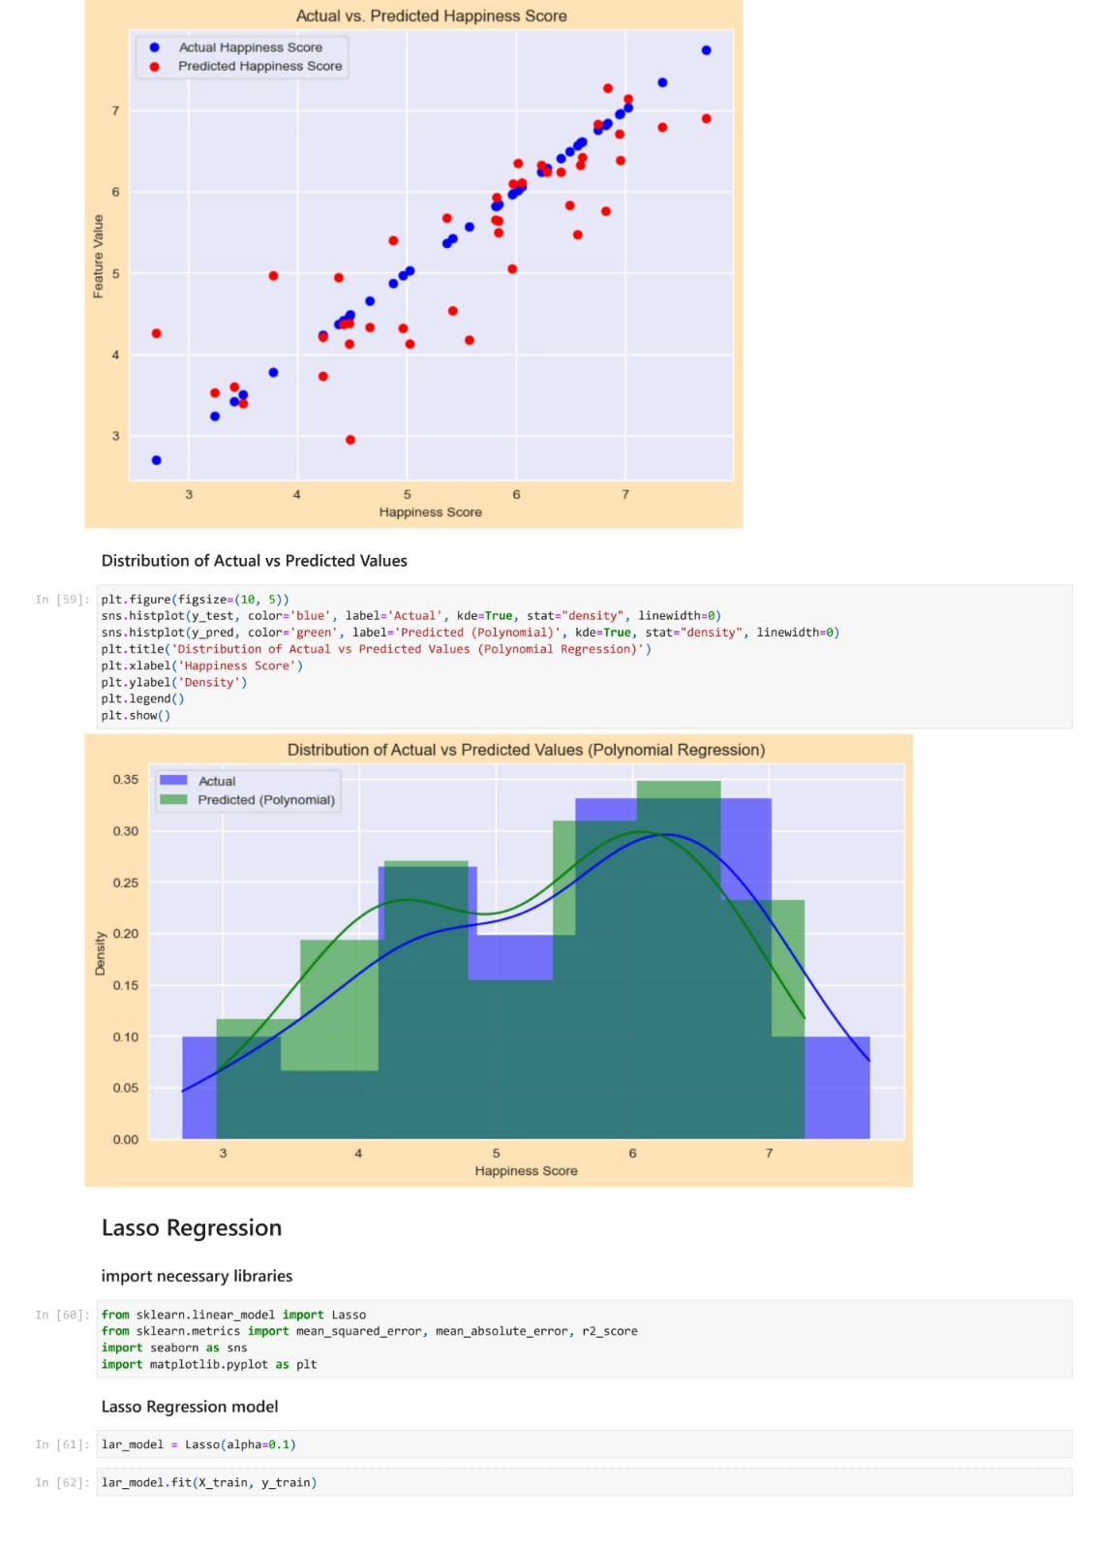

Bibliography

[1] https://www.un.org/en/observances/happiness-day, “International day of Happiness,” United Nations. [Online]. Available: https://www.un.org/en/observances/happiness-day

[2] “International Day of Happiness Theme, History”. https://www.un.org/en/observances/happiness-day

[3] Y. Zhang, “Analyze and Predict the 2022 World Happiness Report Based on the Past Year’s Dataset,” *Journal of Computer Science*, vol. 19, no. 4, pp. 483–492, 2023, doi: 10.3844/jcssp.2023.483.492.

[4] J. F. , L. R. , S. J. D. , D. N. J.-E. , A. L. B. , & W. S. Helliwell, “WHR 2024,” 2024, Accessed: Aug. 28, 2024. [Online]. Available: https://worldhappiness.report/ed/2024/

[5] A. Zhu, “An Analytical View on World Happiness with Unsupervised Machine Learning,” *European Journal of Humanities and Social Sciences*, vol. 2, no. 3, pp. 1–8, May 2022, doi: 10.24018/ejsocial.2022.2.3.216.

[6] L. S. D. Saputri T. R. D, “A Study of Cross-National Differences in Happiness Factors Using Machine Learning Approach.  ,” *International Journal of Software Engineering and Knowledge Engineering.*, 2015.

[7] “Happiness as a sustainability factor. ,” 2017.

[8] IEEE, “A Prediction Model for Human Happiness Using Machine Learning Techniques”.

[9] Prismahardi Aji Riyantoko, “Southeast Asia Happiness Report in 2020 Using Exploratory Data Analysis”.

[10] Farooq S. A and Shanmugam S. K, “A Performance Analysis of Supervised Machine Learning Techniques for COVID-19 and Happiness Report Dataset. Sentimental Analysis and Deep Learning.,” pp. 591–601, 2022.

[11] M. Khder, “Analysis of World Happiness Report Dataset Using Machine Learning Approaches”.

[12] I. H. Sarker, “Machine Learning: Algorithms, Real-World Applications and Research Directions,” May 01, 2021, *Springer*. doi: 10.1007/s42979-021-00592-x.

[13] javapiont, “Structured-data-vs-unstructured-data”.

[14] Rochester N, McCarthy J, and Minsky ML, “ A proposal for the Dartmouth summer research project on artificial intelligence,” AI Mag [Internet] .

[15] J. Haugeland, “ Artificial intelligence: The very idea.    ,” 1989.

[16] R. Bellman, “An introduction to artificial intelligence: Can computers think?,” *Boyd & Fraser. (Ed.)*, 1978.

[17] Rich E & Knight, “Artificial intelligence,” *McGraw-Hill*, 1991.

[18] Niklas Kühl, “Artificial intelligence and machine learning ”.

[19] S. J. Russell and P. Norvig, “ Artificial intelligence: a modern approach,” *Malaysia; Pearson Education Limited*, 2016.

[20] J. R. , B. F. H. , A. D. , & K. M. A. Koza, “Automated design of both the topology and sizing of analog electrical circuits using genetic programming. In J. S. Gero, & F. Sudweeks (Eds.), Artificial Intelligence in Design ’96. Springer. ,” 1996.

[21] Peter Hahn, “Künstliche Intelligenz und Maschinelles Lernen,” 2019.

[22] Han J, Pei J, and Kamber M., “ Data mining: concepts and techniques,” 2011.

[23] Witten IH and Frank E., “Data Mining: Practical machine learning tools and techniques.,” *Morgan Kaufmann*, 2005.

[24] Sarker IH, “Deep cybersecurity: a comprehensive overview from neural network and deep learning perspective.,” . *SN Comput Sci*, 2021.

[25] Sarker IH, Watters P, and Kayes ASM, “Effectiveness analysis of machine learning classification models for predicting personalized context-aware smartphone usage.,” *J Big Data*, vol. 6, no. 1, pp. 1–28, 2019.

[26] “Machine Learning Techniques How does machine learning work?” [Online]. Available: https://www.javatpoint.com/machine-learning-techniques

[27] “What is unsupervised learning_  _  Google Cloud”.

[28] X. J. Zhu, “ Semi-supervised learning literature survey.,” 2005.

[29] L. P. , L. M. L. , & M. A. W. Kaelbling, “Reinforcement learning: A survey.,” *Journal of Artificial Intelligence Research.*, vol. 4, pp. 237–285, 1996.

[30] javapoint, “Decision tree classification algorithm”.

[31] “Introduction to Machine Learning-The MIT Press (2014)”.

[32] javapoint, “Hierarchical-clustering-in-machine-learning.”

[33] javapoint, “machine-learning-algorithms.”

[34] javapoint, “machine-learning-models.” Accessed: Aug. 28, 2024. [Online]. Available: https://www.javatpoint.com/machine-learning-models

[35] Tutorials Point (I) Pvt. Ltd. ebook, “Machine Learning,” 2019.

[36] Artem Oppermann, “deep-learning,” Built in.

[37] “Python,” PSF.

[38] javapoint, “Python history.”

[39] javapoint, “Python Libraries.”

[40] javapoint, “Role-of-python-in-artificial-intelligence.”

[41] “Role of Python in AI,” Cyber Sucess.

[42] “Data Preprocessing in Machine learning Why do we need Data Preprocessing?” [Online]. Available: https://www.kaggle.com/uciml/datasets,

[43] S. Wu, “A review on coarse warranty data and analysis,” pp. 1–11, 2013.

[44] Praneeta, “Data Cleaning in Python | What is Data Cleaning?”

[45] Malay Agarwal, “Pythonic Data Cleaning With pandas and NumPy.”

[46] “Step-by-Step Exploratory Data Analysis (EDA) using Python -”.

[47] javapoint, “What-is-exploratory-data-analysis.”

[48] Ravikiran A S, “what_is_data_visualization,” Simplilearn.

[49] Javapoint, “packages-of-data-visualization-in-python.”

[50] “WHR 2023”.

[51] bigdataframework, “The-difference-between-data-wrangling-and-data-cleaning.”

[52] D. Stubbs, “Creator: Creative-Touch | Credit: Getty Images Copyright: Creative-Touch World Happiness Exploratory Data & Regression Analysis,” 2022. [Online]. Available: https://www.linkedin.com/pulse/world-happiness-exploratory-data-regression-analysis-diondra-stubbs

[53] K. Bhowmick and C. Ranjit, “Mapping the Statistical Significance of Factors Contributing to the World Happiness Report,” *Int J Eng Adv Technol*, vol. 10, no. 6, pp. 28–37, Aug. 2021, doi: 10.35940/ijeat.F2963.0810621.